WP6.1 - Learning Needs Characterised by Training Demand, Importance & Impact
Jessie Roberts
04 July 2026
Table of Contents

1 Executive Summary
This report presents the findings of Work Package 6.1, which sought to understand the learning needs of Australian health and medical researchers in advanced analytics and artificial intelligence (AI). Drawing on survey responses from 99 respondents, the survey assessed 57 research tools and methods across four domains: programming and data science platforms, statistical and machine learning methods, domain-specific health analytics tools, and AI/LLM platforms. For each tool, respondents reported their current use, current skill level, and priority for training in the next 18 months, from which Training Demand, Training Importance, and Training Impact scores were derived. The survey also captured respondents’ preferred learning formats, time commitments, motivations, and barriers to training participation.
Deliverable: a ranked list of training needs, characterised by demand, importance, and potential impact, to inform the resource hub’s training content and discovery tool (Work Packages 6.2–6.5).
Key findings
Training demand was diverse, with some demand present across nearly every tool surveyed. Electronic Health Records (EHR) analytics, Computer Vision & Medical Imaging Analysis, and NLP models (BERT, bioBERT, etc) each had more than 40% of respondents indicating they do not currently use the tool but would like to. When ranked by Training Demand, Importance, and Impact combined, EHR analytics, R, Causal Analysis, Regression, and SQL & Database management were the top 5 tools, with EHR analytics ranking first overall on the strength of its Training Impact Score, reflecting both strong interest in using the tool and a substantial skill gap.
Learning preferences were similarly diverse, though clear patterns emerged. One-on-one mentoring, self-paced online courses, and video tutorials were the most preferred learning formats, while hands-on projects and conference workshops were the least preferred (52% and 39% of respondents rated each “not preferred at all,” respectively). Short courses and half-day workshops were the most preferred time commitments (97% and 94% somewhat or most preferred, respectively), while semester-long courses were clearly the least preferred.
Respondents were motivated to participate in training primarily to develop skills for specific projects or to meet the requirements of their current or future roles. Structured incentives, formal certification, CPD credits, and priority access to compute resources, were, at most, modest motivators: close to half of respondents rated each as “not a motivator,” and only around one in five rated them as “highly motivating.” Time availability was the dominant barrier to training participation, ahead of cost/licensing and awareness of quality training, underscoring the value of flexible, short-format training and as well as discovery tools that support researcher identify relevant training. Highlighting the importance of the discovery tool detailed in Work Packages 6.4 and 6.5.
Work Package 6.1 has been an important step in understanding the training and learning needs of the health research community, and its findings will inform the design of the training resource search protocol in Work Packages 6.2 and 6.3, and the training discovery tool in Work Package 6.4.

2 Background
The Australian Research Data Commons (ARDC) health analytics resource hub aims to build capability in advanced analytics and artificial intelligence (AI) across the Australian health research community. To ensure the hub addresses genuine community needs, Work Package 6.1 sought to identify and characterise the community’s learning needs through consultation, including focus groups and an online survey. This report summarises the findings of the online survey.

3 Methods
This section describes the survey questions relevant to Work Package 6.1 (learning needs) and the approach used to calculate Training Demand, Training Importance, and Training Impact scores for each tool.

3.1 Development of Tool List
A list of 57 analytics and research tools was compiled from focus group summaries and input from the project team. These tools formed the basis for the survey questions designed to characterise the health research community’s learning needs.

3.2 What Was Measured
Learning needs were assessed across two dimensions:
What researchers need to learn - Respondents were presented with 57 tools, methods, and platforms and asked to indicate their current use on a four-point scale: Currently use, Would like to use, Neither want nor need to use, Unsure what this is / Don’t know enough about.
For each tool a respondent indicated they currently use or would like to use, two follow-up questions were presented: (1) current skill level, and (2) priority for engaging in training in the next 18 months.
- Current skill level (four-point scale): None, Beginner, Intermediate, Advanced
- Priority for training in the next 18 months (three-point scale): Not a priority, Somewhat a priority, High priority
How researchers want to learn: Respondents rated a range of delivery formats and time commitment options on a three-point preference scale (Not preferred at all, Somewhat preferred, Most preferred), and identified their motivations for, and barriers to, training participation.
Delivery format options (12):
- Self-paced online courses
- Live online workshops
- In-person workshops
- One-on-one mentoring
- Peer learning groups
- Documentation and tutorials
- Video tutorials
- Hands-on projects
- Conference workshops
- Certification programs
- Reading research papers
- Other
Time commitment options (9):
- Micro-learning (15–30 min sessions, just-in-time)
- Short courses (1–2 hours, single topic)
- Half-day workshops (3–4 hours)
- Full-day workshops (6–8 hours)
- Multi-week courses (2–3 hours/week over 4–8 weeks)
- Intensive bootcamps (multiple full days)
- Semester-long courses (10–15 weeks)
- Self-paced (complete at own speed over months)
- Other

3.3 Handling of Non-Response
Not every respondent who answered a tool’s usage question went on to answer that tool’s skill level and training priority follow-up questions. The treatment of non-response differs between these two measures, reflecting a difference in what can reasonably be inferred.
Training priority is imputed from the usage response where the inference is logically defensible, since both measures speak to the same underlying construct: future intent toward the tool. A respondent who indicated they “neither want nor need” a tool is recorded as having “Not a priority” for training in it; a respondent who indicated “don’t know enough” about a tool is recorded as “don’t know enough” for training priority. Respondents who indicated they “currently use” or “would like to use” a tool, but did not answer the training priority question, are recorded as “No response” – a genuine non-answer, since no inference can be drawn from their usage response alone.
Current skill level is never imputed. A usage response tells us about a respondent’s interest in or awareness of a tool, but not about their actual competence with it – a respondent could retain real prior skill in a tool they no longer wish to use. Every respondent without a directly-answered skill response is therefore recorded as “No response”, regardless of their usage response.
One consequence of this approach is that Training Impact Score and Total Score are undefined (NA) for any tool where no respondent provided a direct skill response at all. This occurs for a small number of tools that were inadvertently omitted from the skill and training priority follow-up questions when the survey instrument was constructed; see Notable Anomalies for the full list of affected tools and how this was addressed in the tool shortlist carried forward to Work Package 6.2.

3.4 How Learning Needs Were Scored
To rank tools in terms of the community’s learning needs, three scores were assigned to each tool: Training Demand, Training Importance, and Training Impact.
Training Demand Score: A measure of intent to engage in training for a specific tool or method within the next 18 months. A weighting of 1.5 is applied to the proportion of respondents who indicated training was a high priority, relative to those who indicated it was somewhat a priority.
$$\begin{matrix}\text{Training Demand Score}=\left(\%\text{ High priority}×1.5\right)+\%\text{ Somewhat a priority}\end{matrix}$$
Training Importance Score: A measure of a tool’s importance within the current health research workflow, combining demand for training with demand for the tool itself. A tool with high training demand but a small user base will score lower than one with equivalent training demand but broader uptake. In this way, tools that are central to the research community are weighted more heavily.
$$\begin{matrix}\text{Training Importance Score}=\text{Training Demand Score}×\text{Tool Demand Score}\end{matrix}$$
Where:
$$\begin{matrix}\text{Tool Demand Score}=\%\text{ Currently use}+\%\text{ Would like to use}\end{matrix}$$
Training Impact Score: Identifies training opportunities with the greatest potential for positive impact by combining tool demand with the magnitude of the existing skill gap. Tools for which there is both strong demand and a large proportion of users at low skill levels are those for which training is likely to be most transformative.
$$\begin{matrix}\text{Training Impact Score}=\text{Tool Demand Score}×\text{Skill Gap Score}\end{matrix}$$
Where:
$$\begin{matrix}\text{Skill Gap Score}= & 2×\left(\%\text{ Beginner}+\%\text{ None}\right) \\ & +1×\%\text{ Intermediate} \\ & +0.5×\%\text{ Advanced}\end{matrix}$$

4 Results

4.1 Survey Respondents
99 respondents completed the survey. The majority were based in Australia (77.8%), consistent with the project’s focus on the Australian health research community. Respondents’ research areas were diverse, with Computational/data science the single largest group (21.2%), followed by Population health/epidemiology (16.2%); the remaining respondents were spread across research areas. By career stage, the largest single group was Professional/technical staff (29.3%), followed by Senior researchers (14.1%), Students (13.1%), Mid-career researchers (9.1%), and Early career researchers (8.1%). By primary position, respondents were fairly evenly split between Academic Researchers (24.2%), Analysts/Technical officers (22.2%), and Managers/Directors/Leadership (22.2%), with a smaller group of postgraduate students (8.1%).
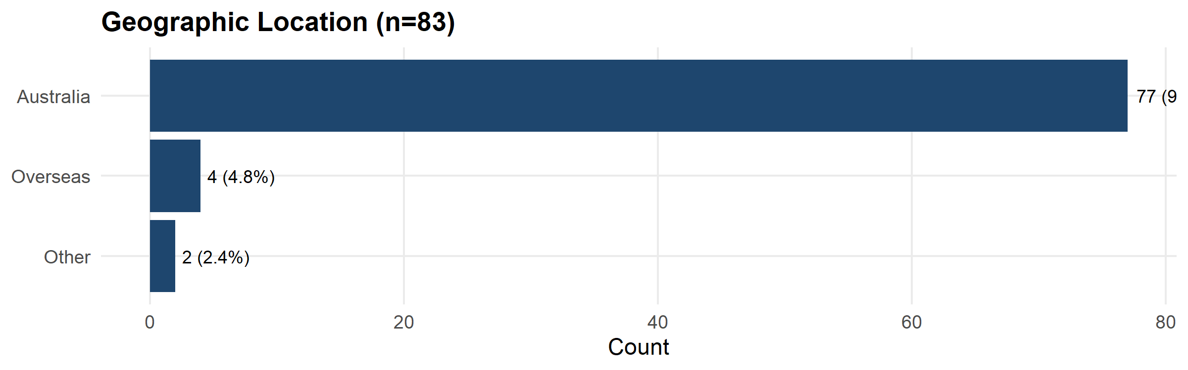
Figure 1: Geographic location of respondents.
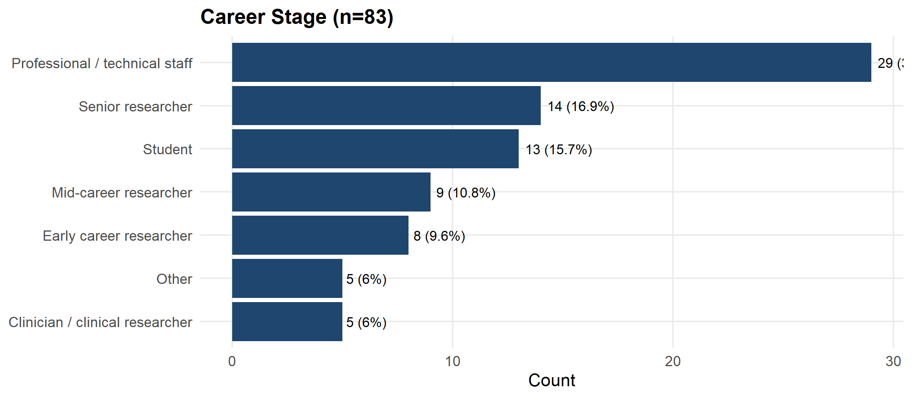
Figure 2: Career stage of respondents.
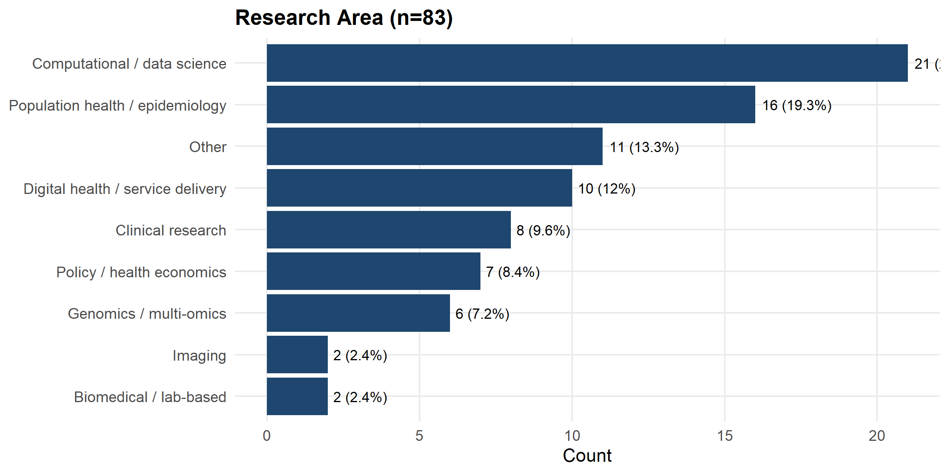
Figure 3: Research area of respondents.
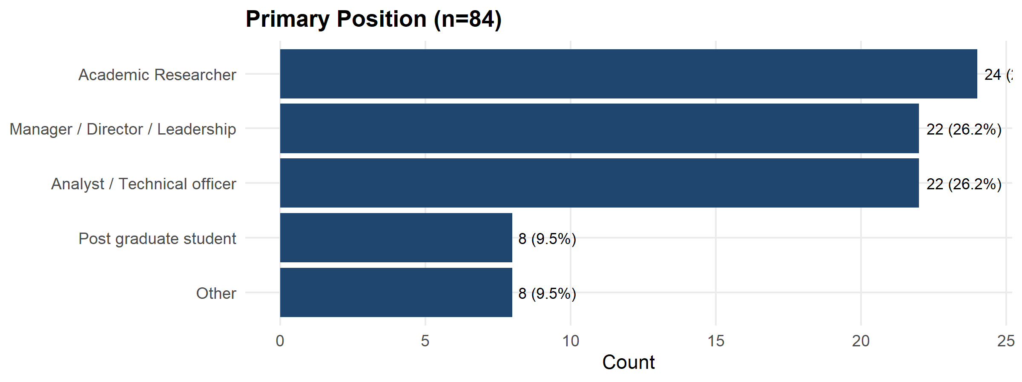
Figure 4: Primary position of respondents.
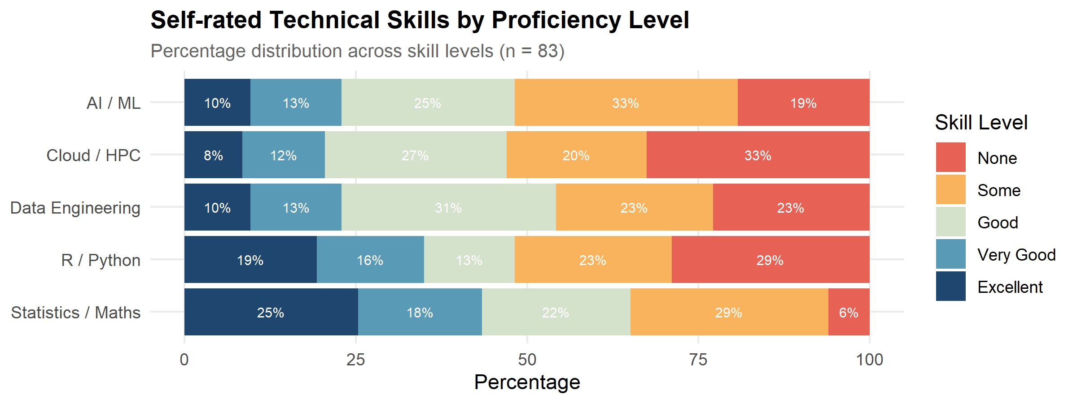
Figure 5: Self-rated digital skills of respondents across 10 skill areas (Q6).

4.2 Which tools are the community currently using? Which tools would they like to use more?
The plots below show the percentage of respondents that use each tool.
Electronic Health Records (EHR) analytics, Computer Vision & Medical Imaging Analysis, and NLP models (BERT, bioBERT, etc) were all tools where more than 40% of respondents stated they do not currently use, but would like to use.
Regression and Machine Learning had the highest combined score for currently use and would like to use (97.6% and 90.2% respectively).

4.2.1 Programming Languages, IDEs & Data Science Platforms
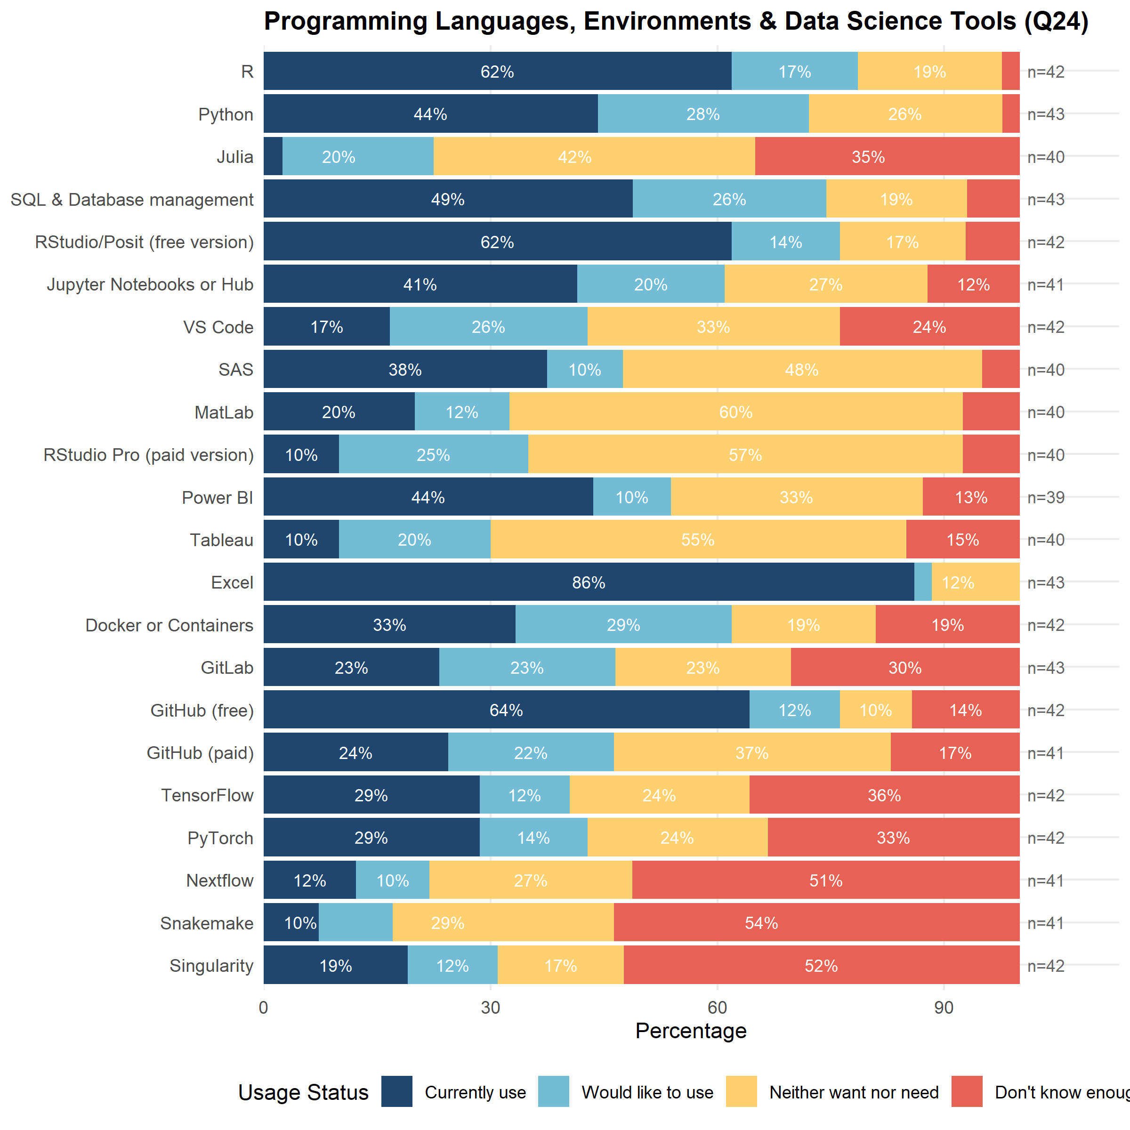
Figure 6: Current usage: programming languages, IDEs, and data science platforms (Q24).

4.2.2 Statistical and Machine Learning Methods
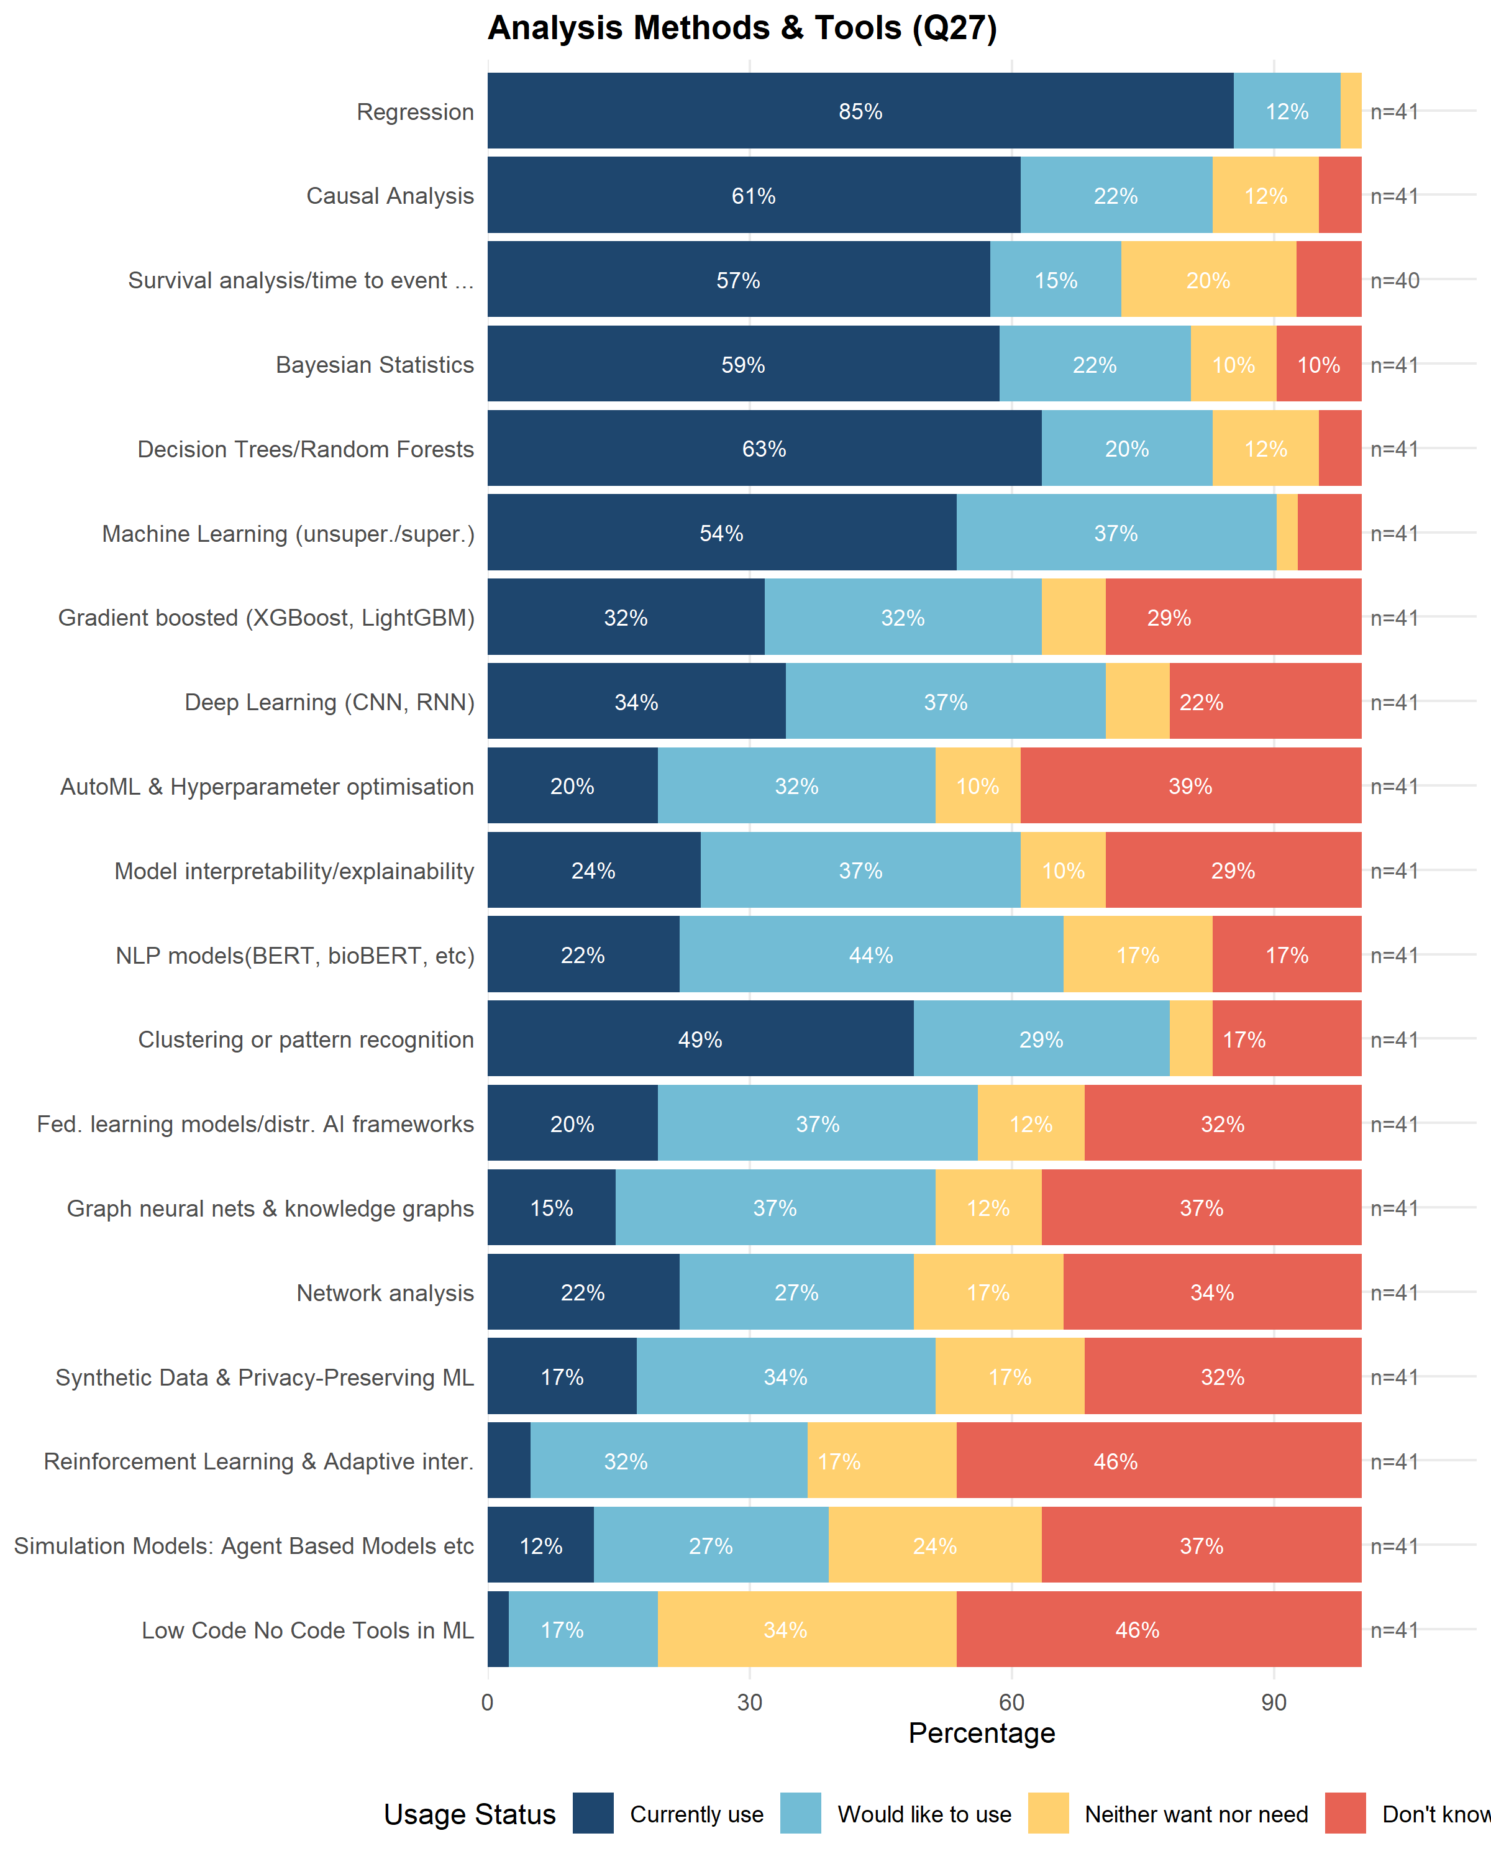
Figure 7: Current usage: Analytical Methods & Tools (Q27).

4.2.3 Domain-Specific Health Analytics Tools
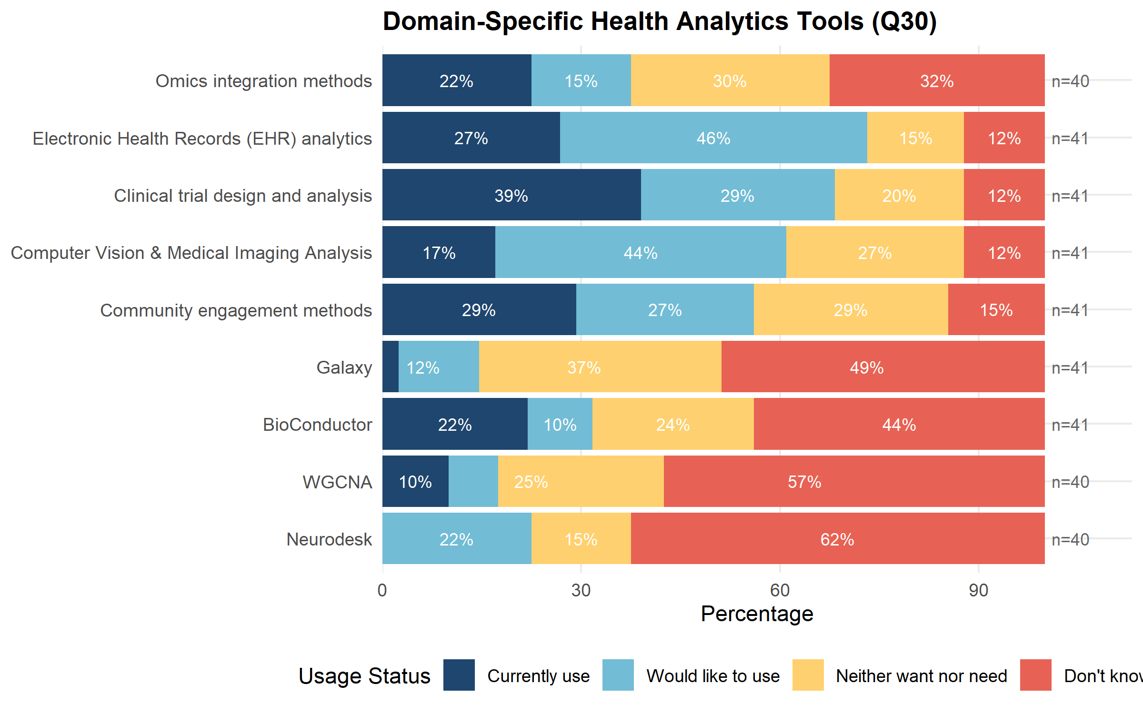
Figure 8: Current usage: domain-specific health analytics tools (Q30).

4.2.4 AI and Large Language Model Tools
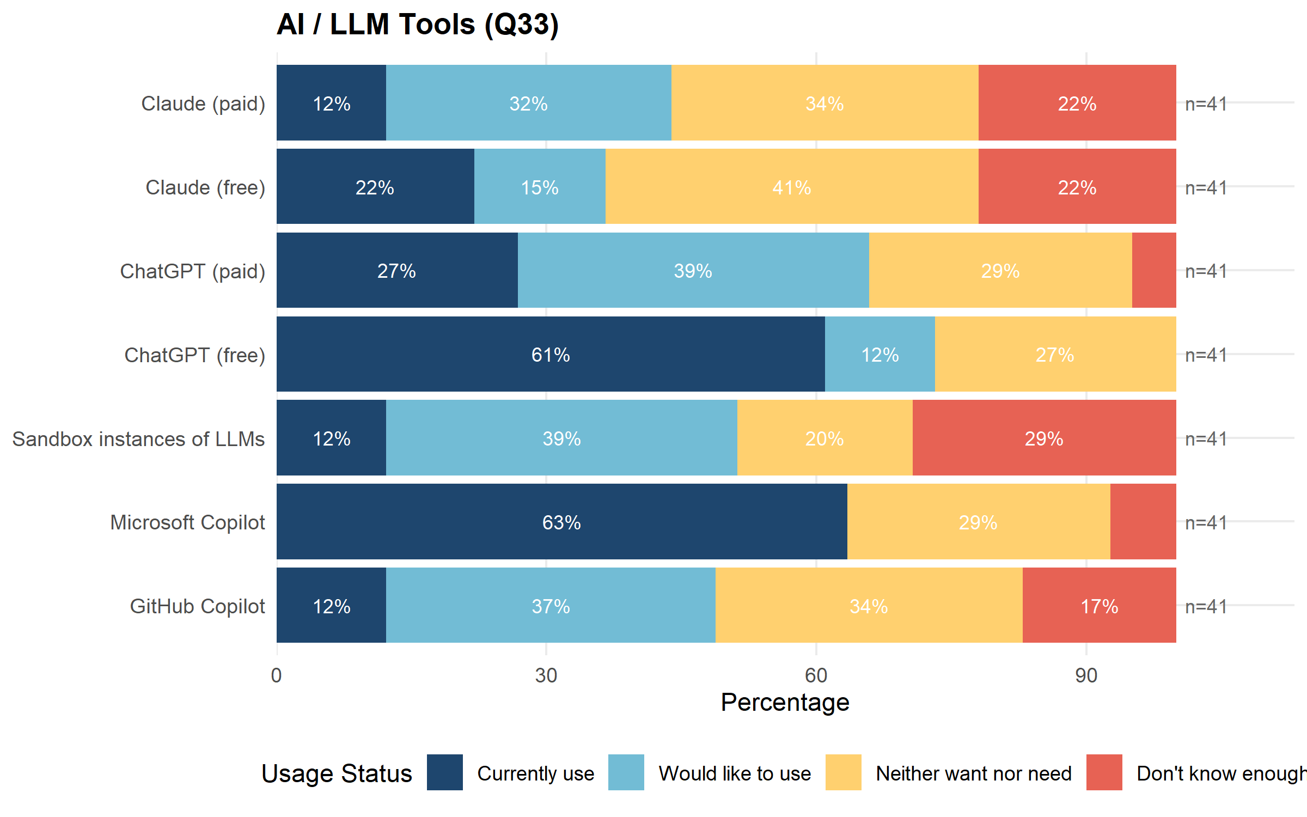
Figure 9: Current usage: AI and LLM tools (Q33).

4.2.5 Additional Tools Identified by Respondents
In addition to the 57 tools explicitly listed in the survey, respondents identified further tools they use via open-text follow-up questions. These are listed in Table 1 below.
Table 1: Additional tools and methods identified via open-text responses.
Domain | Tool/Language | Times Mentioned
Programming tools | stata | 5
Programming tools | antigravity (google) | 1
Programming tools | c | 1
Programming tools | cuda | 1
Programming tools | episerv | 1
Programming tools | fortran | 1
Programming tools | linux command line | 1
Programming tools | mplus | 1
Programming tools | ms office | 1
Programming tools | opendatafit | 1
Programming tools | positron | 1
Statistical/ML methods | any graphical representation of results | 1
Statistical/ML methods | bayesian optimisation | 1
Statistical/ML methods | enformer etc) | 1
Statistical/ML methods | genome language models (e.g. alphagenome | 1
Domain-specific tools | mass spectrometry data | 1
Domain-specific tools | plate reader data | 1
AI/LLM tools | google gemini | 2
AI/LLM tools | gemini | 1
AI/LLM tools | grok | 1
AI/LLM tools | le chat (mistral) | 1
AI/LLM tools | mistral | 1
AI/LLM tools | nexa | 1
AI/LLM tools | notebooklm | 1
AI/LLM tools | ollama | 1
AI/LLM tools | perplexity | 1
AI/LLM tools | prism | 1
AI/LLM tools | research rabbit | 1
Tools and languages extracted from open-text responses.
See Work Package 5 for further discussion of tool demand.
A substantial proportion of respondents (29%) indicated they did not know enough about Sandbox Instances of LLMs to say whether they would like to use the tool. This points to an awareness gap rather than a demand gap: before training can be effective for some emerging tools, researchers may first need to know the tool exists and what it offers.

4.3 Current Skill Level by Tool
For each tool a respondent indicated they currently use or would like to use, they were asked to rate their current skill level. The plots below show the range of skill levels across respondents for each tool group.
Among respondents who answered the skill question NLP models (85.0%) and Community engagement methods (84.4%) had the largest skill gaps, with most respondents who answered rating themselves None or Beginner. Electronic Health Records (EHR) analytics, Causal Analysis, SQL & Database management, Clinical trial design and analysis, GitHub, and Clustering or pattern recognition each had a more moderate, but still substantial, skill gap of around 48% to 54%. By contrast, R and Regression had the smallest skill gaps among the top 10 tools (32% and 33% respectively), indicating that most respondents interested in these two tools already have some existing skill; their high ranking reflects strong demand rather than a large skill gap.

4.3.1 Programming Languages, IDEs & Data Science Platforms
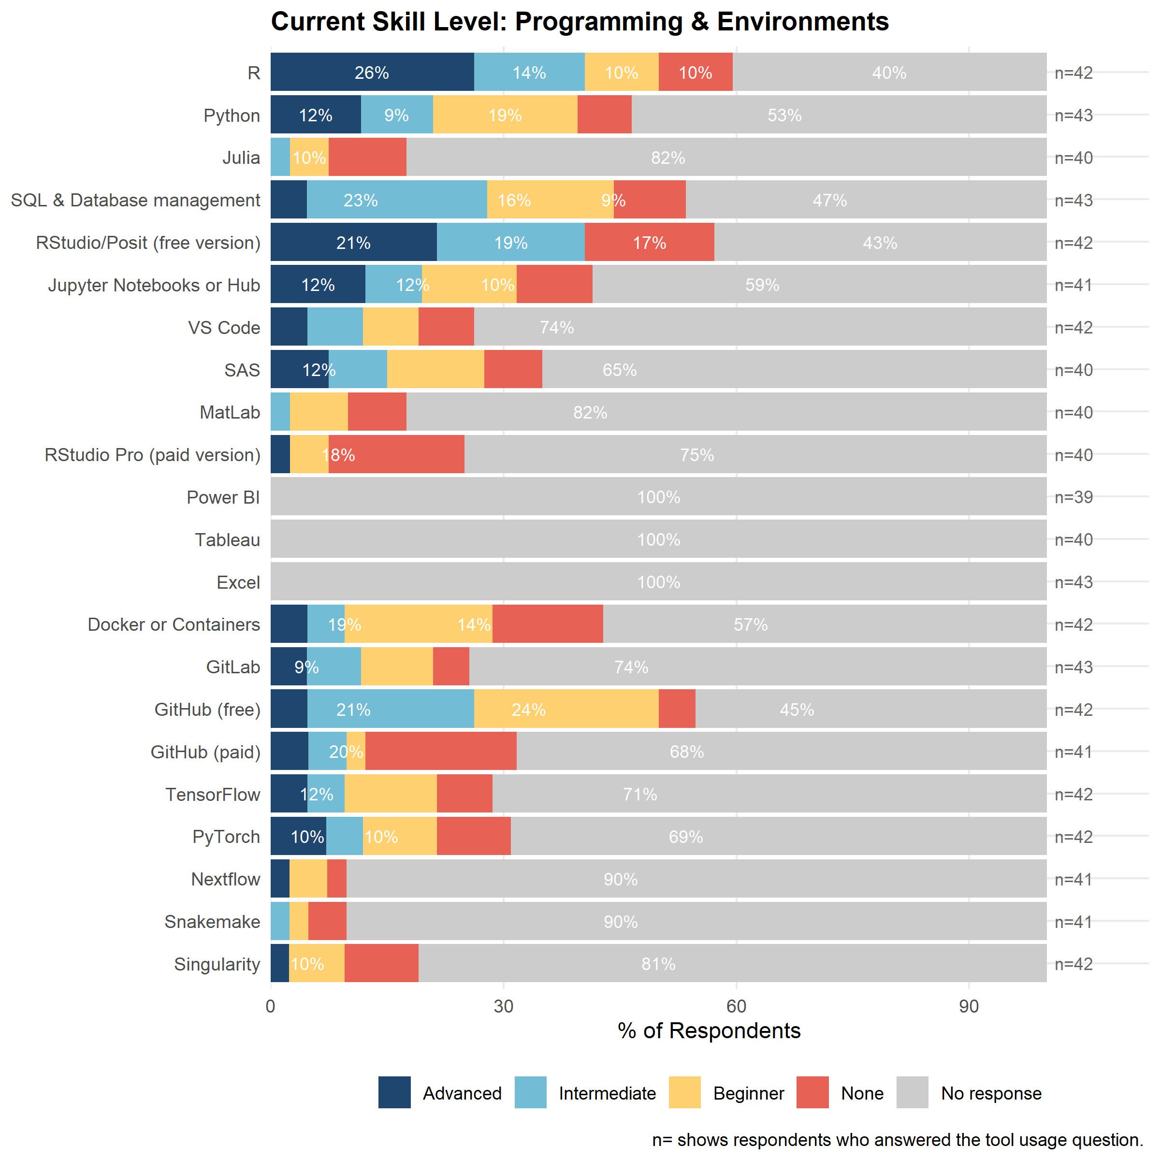
Figure 10: Self-rated current skill level: programming languages, IDEs, and data science platforms (Q47).

4.3.2 Statistical and Machine Learning Methods
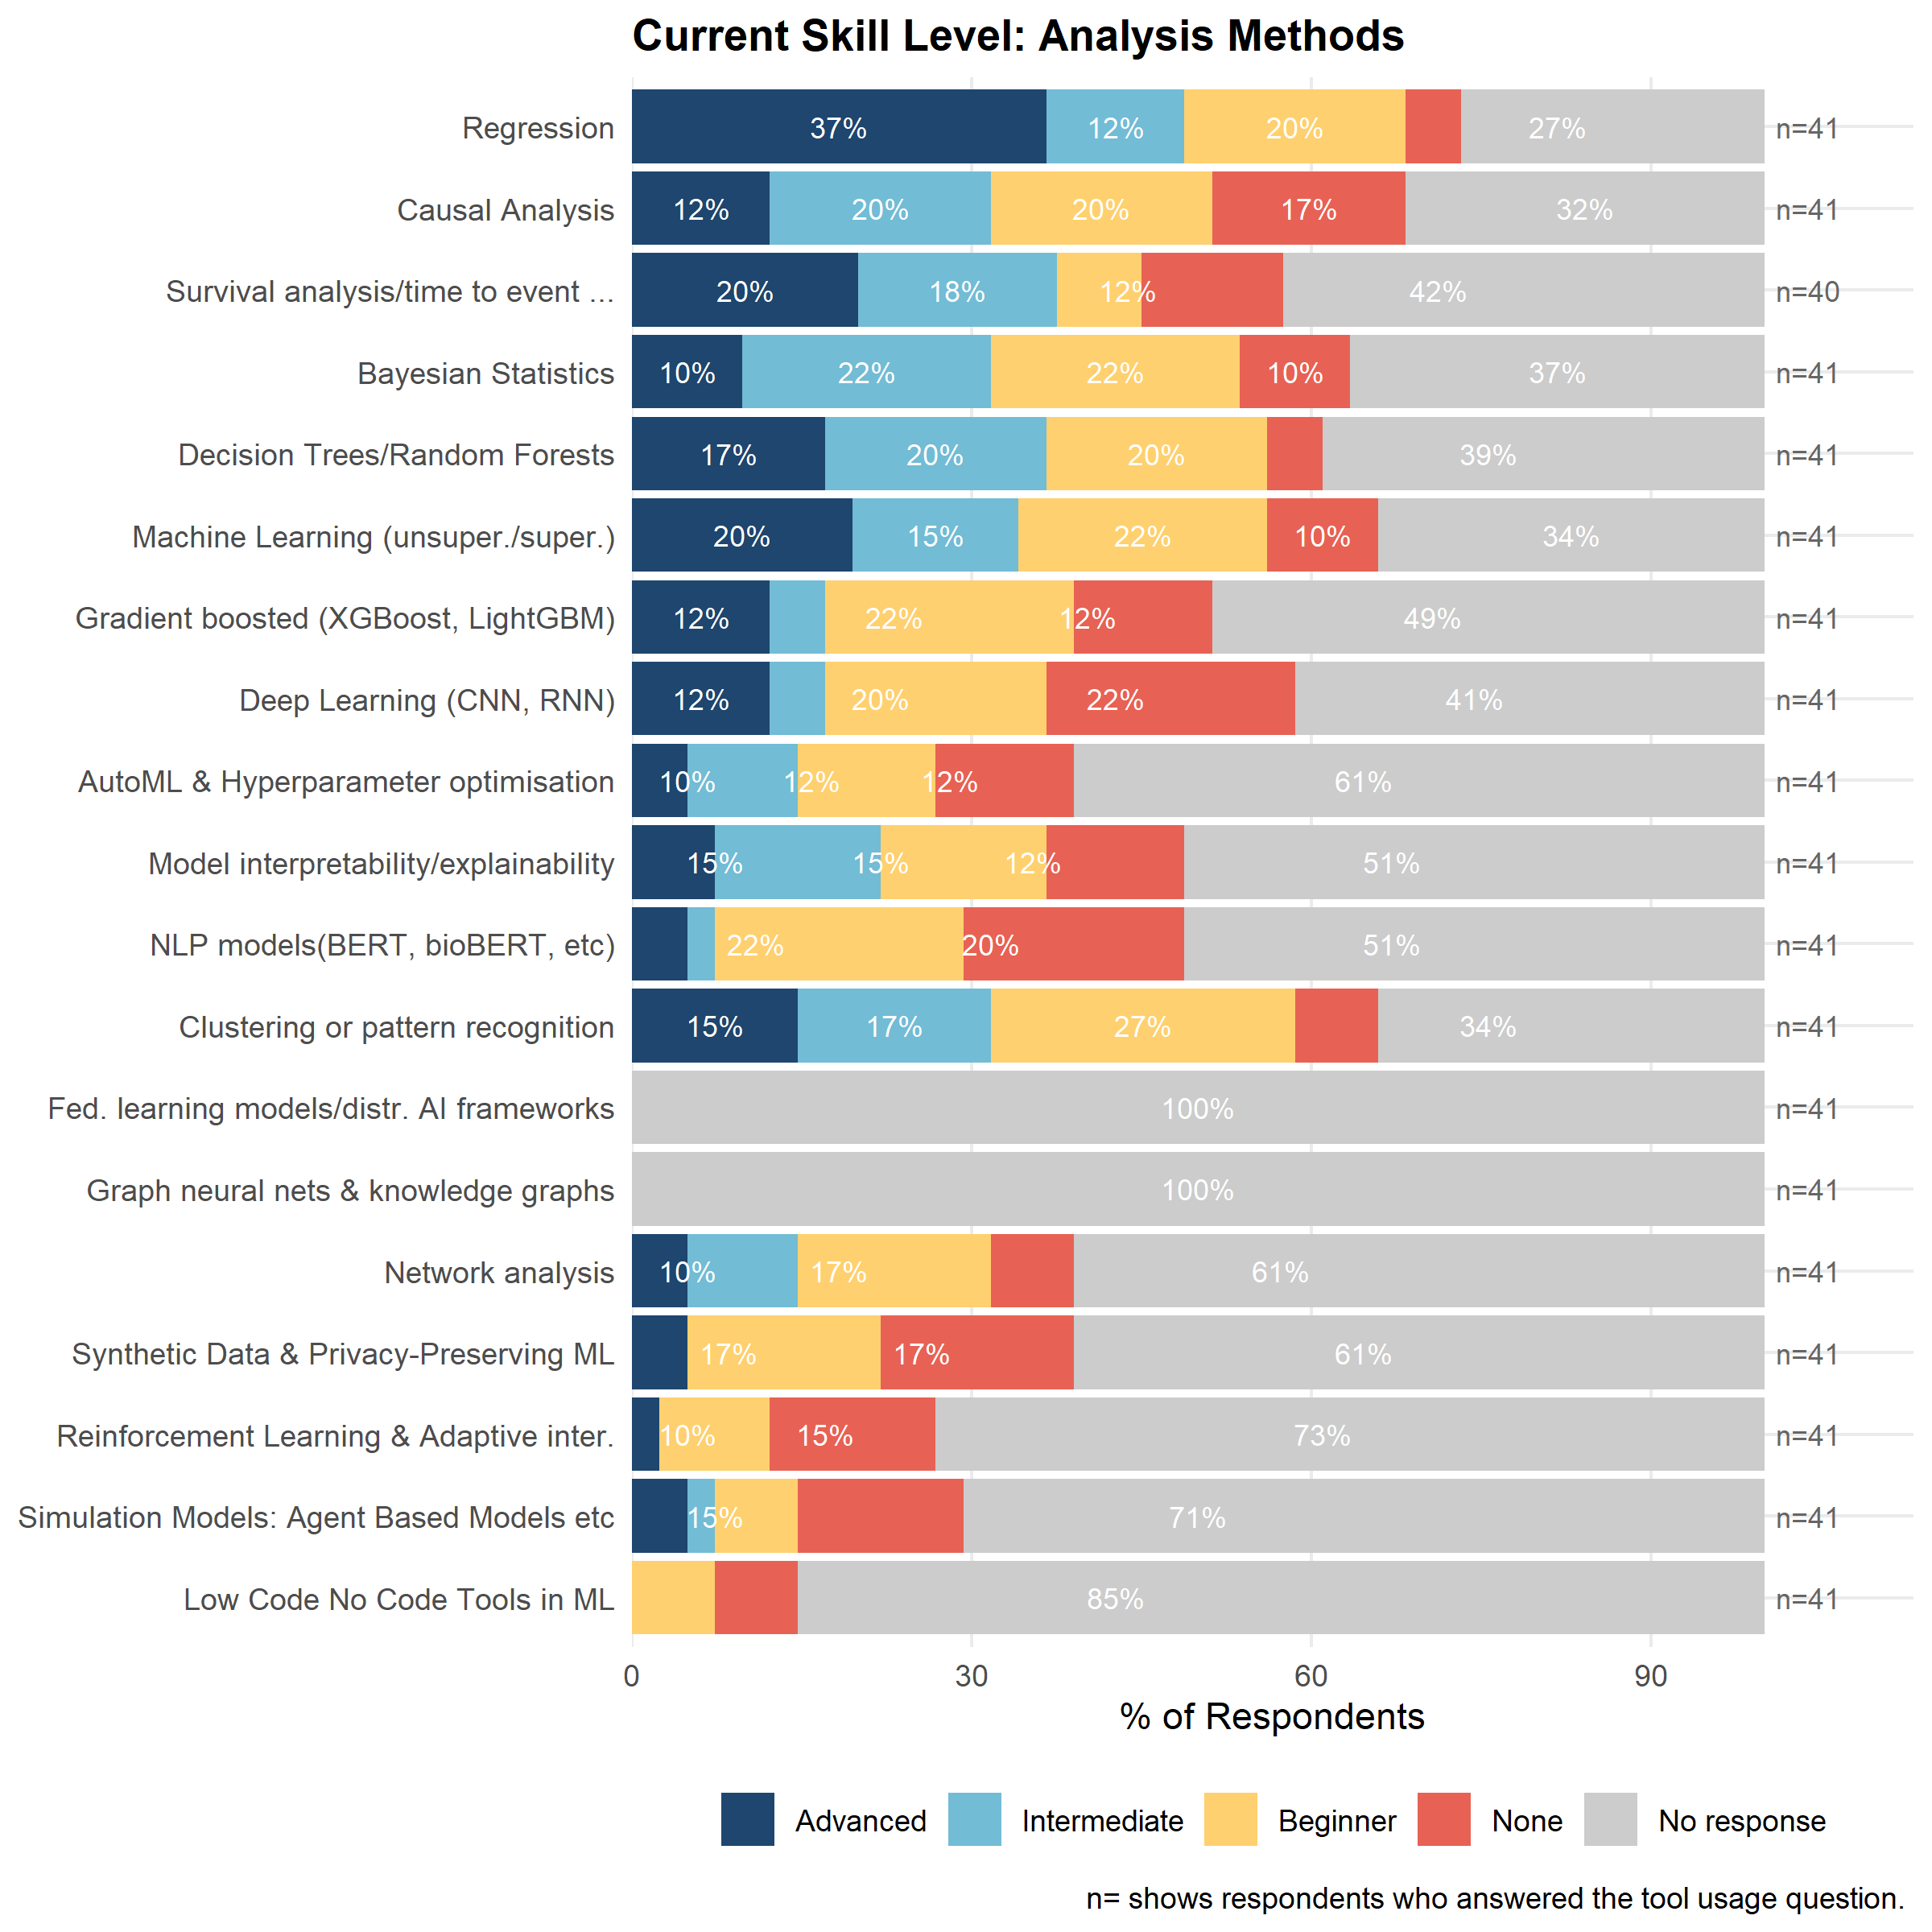
Figure 11: Self-rated current skill level: statistical and machine learning methods (Q48).

4.3.3 Domain-Specific Health Analytics Tools
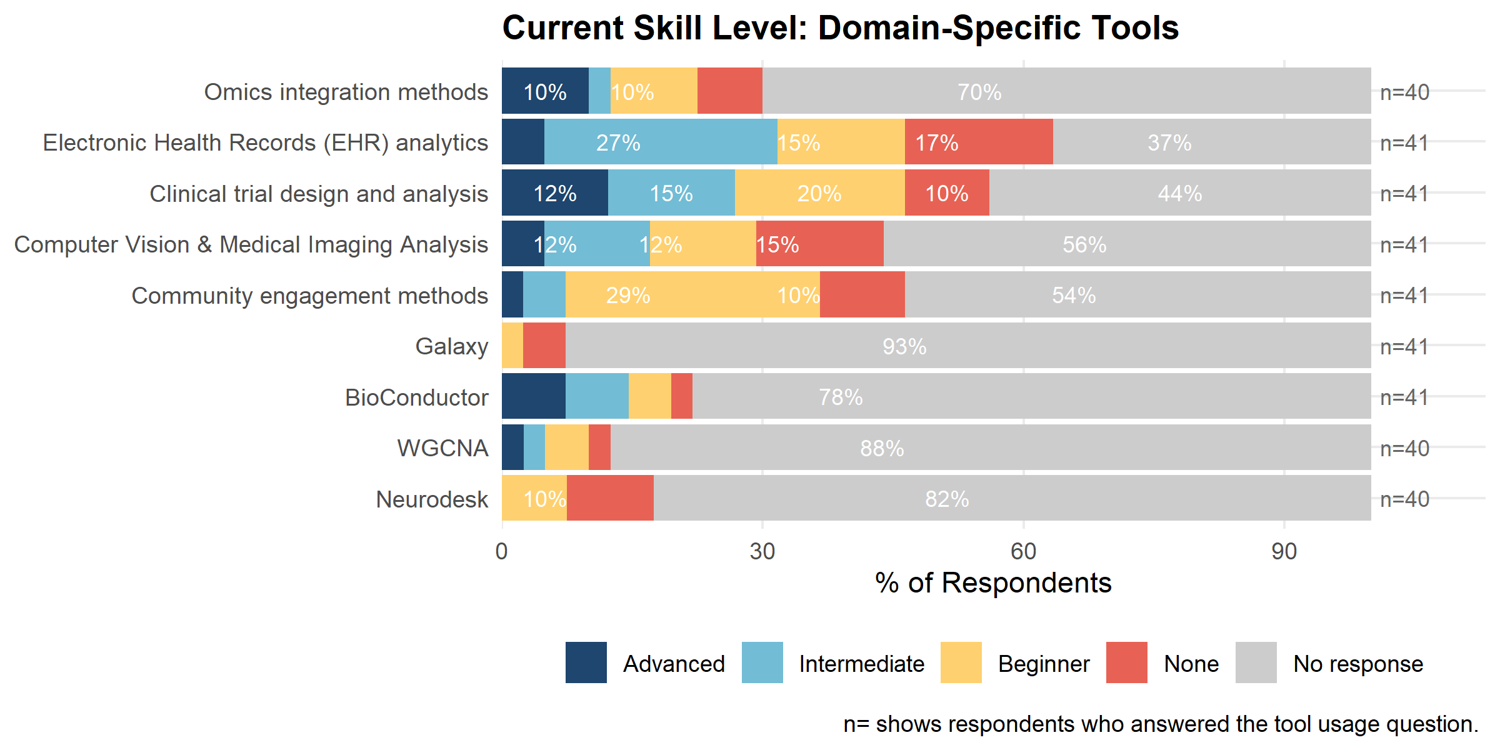
Figure 12: Self-rated current skill level: domain-specific health analytics tools (Q49).

4.3.4 AI and Large Language Model Tools
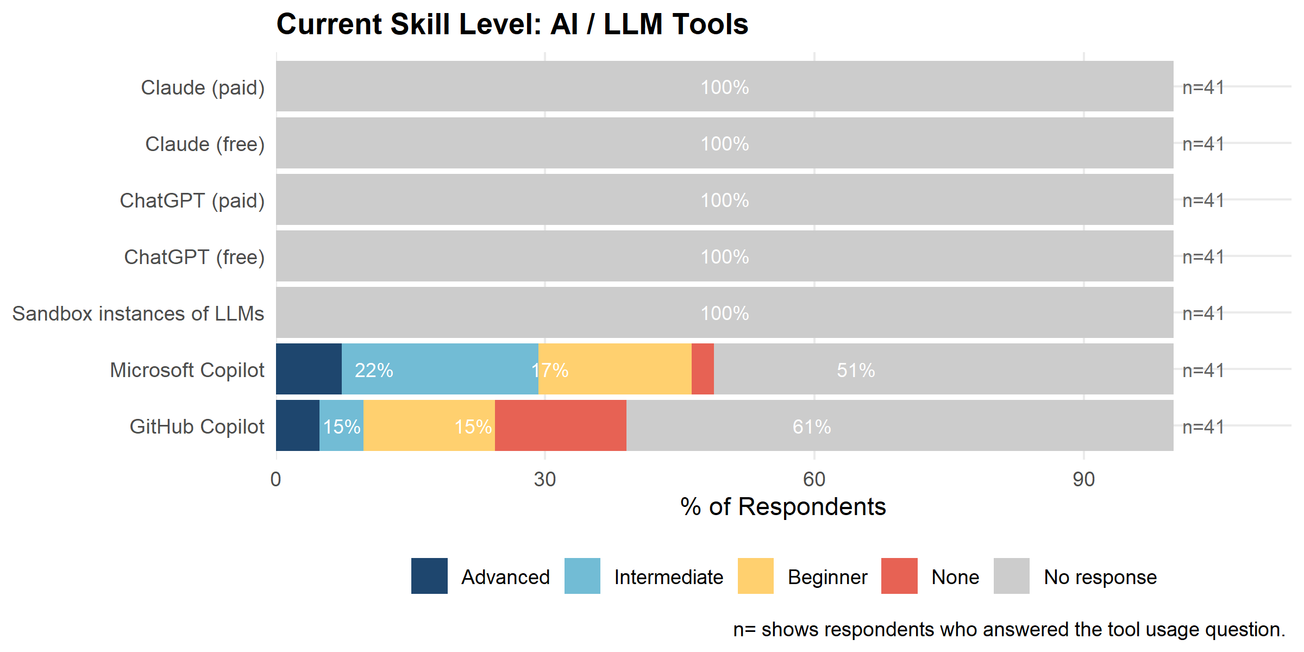
Figure 13: Self-rated current skill level: AI and LLM tools (Q50).

4.4 Demand for Training
The following plots show respondents’ priority for engaging in training in the next 18 months for each tool, separated by tool domain. The top 10 tools by Training Demand Score (% high priority + % somewhat a priority) are listed in Table 2.
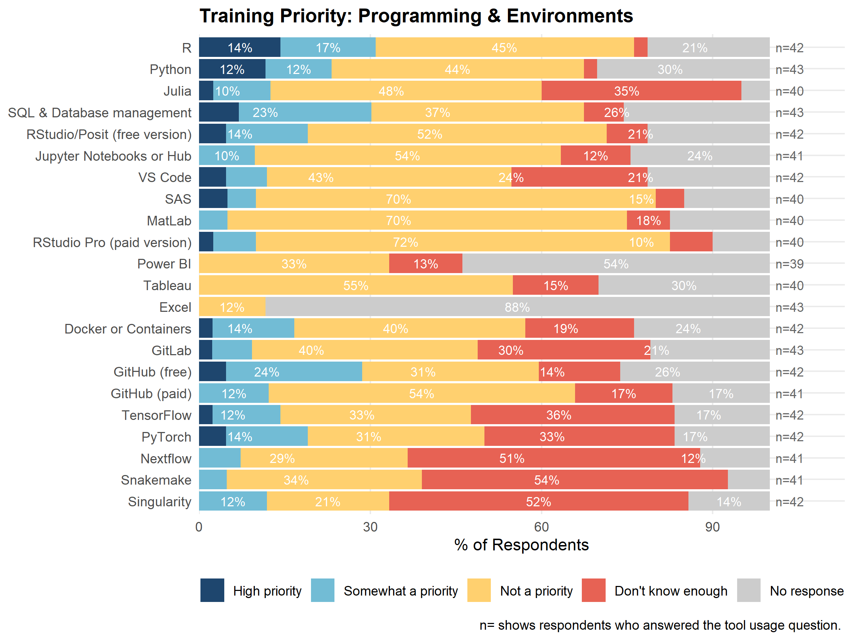
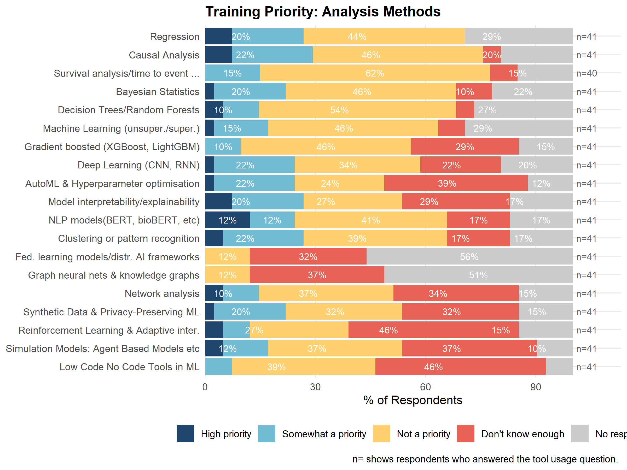
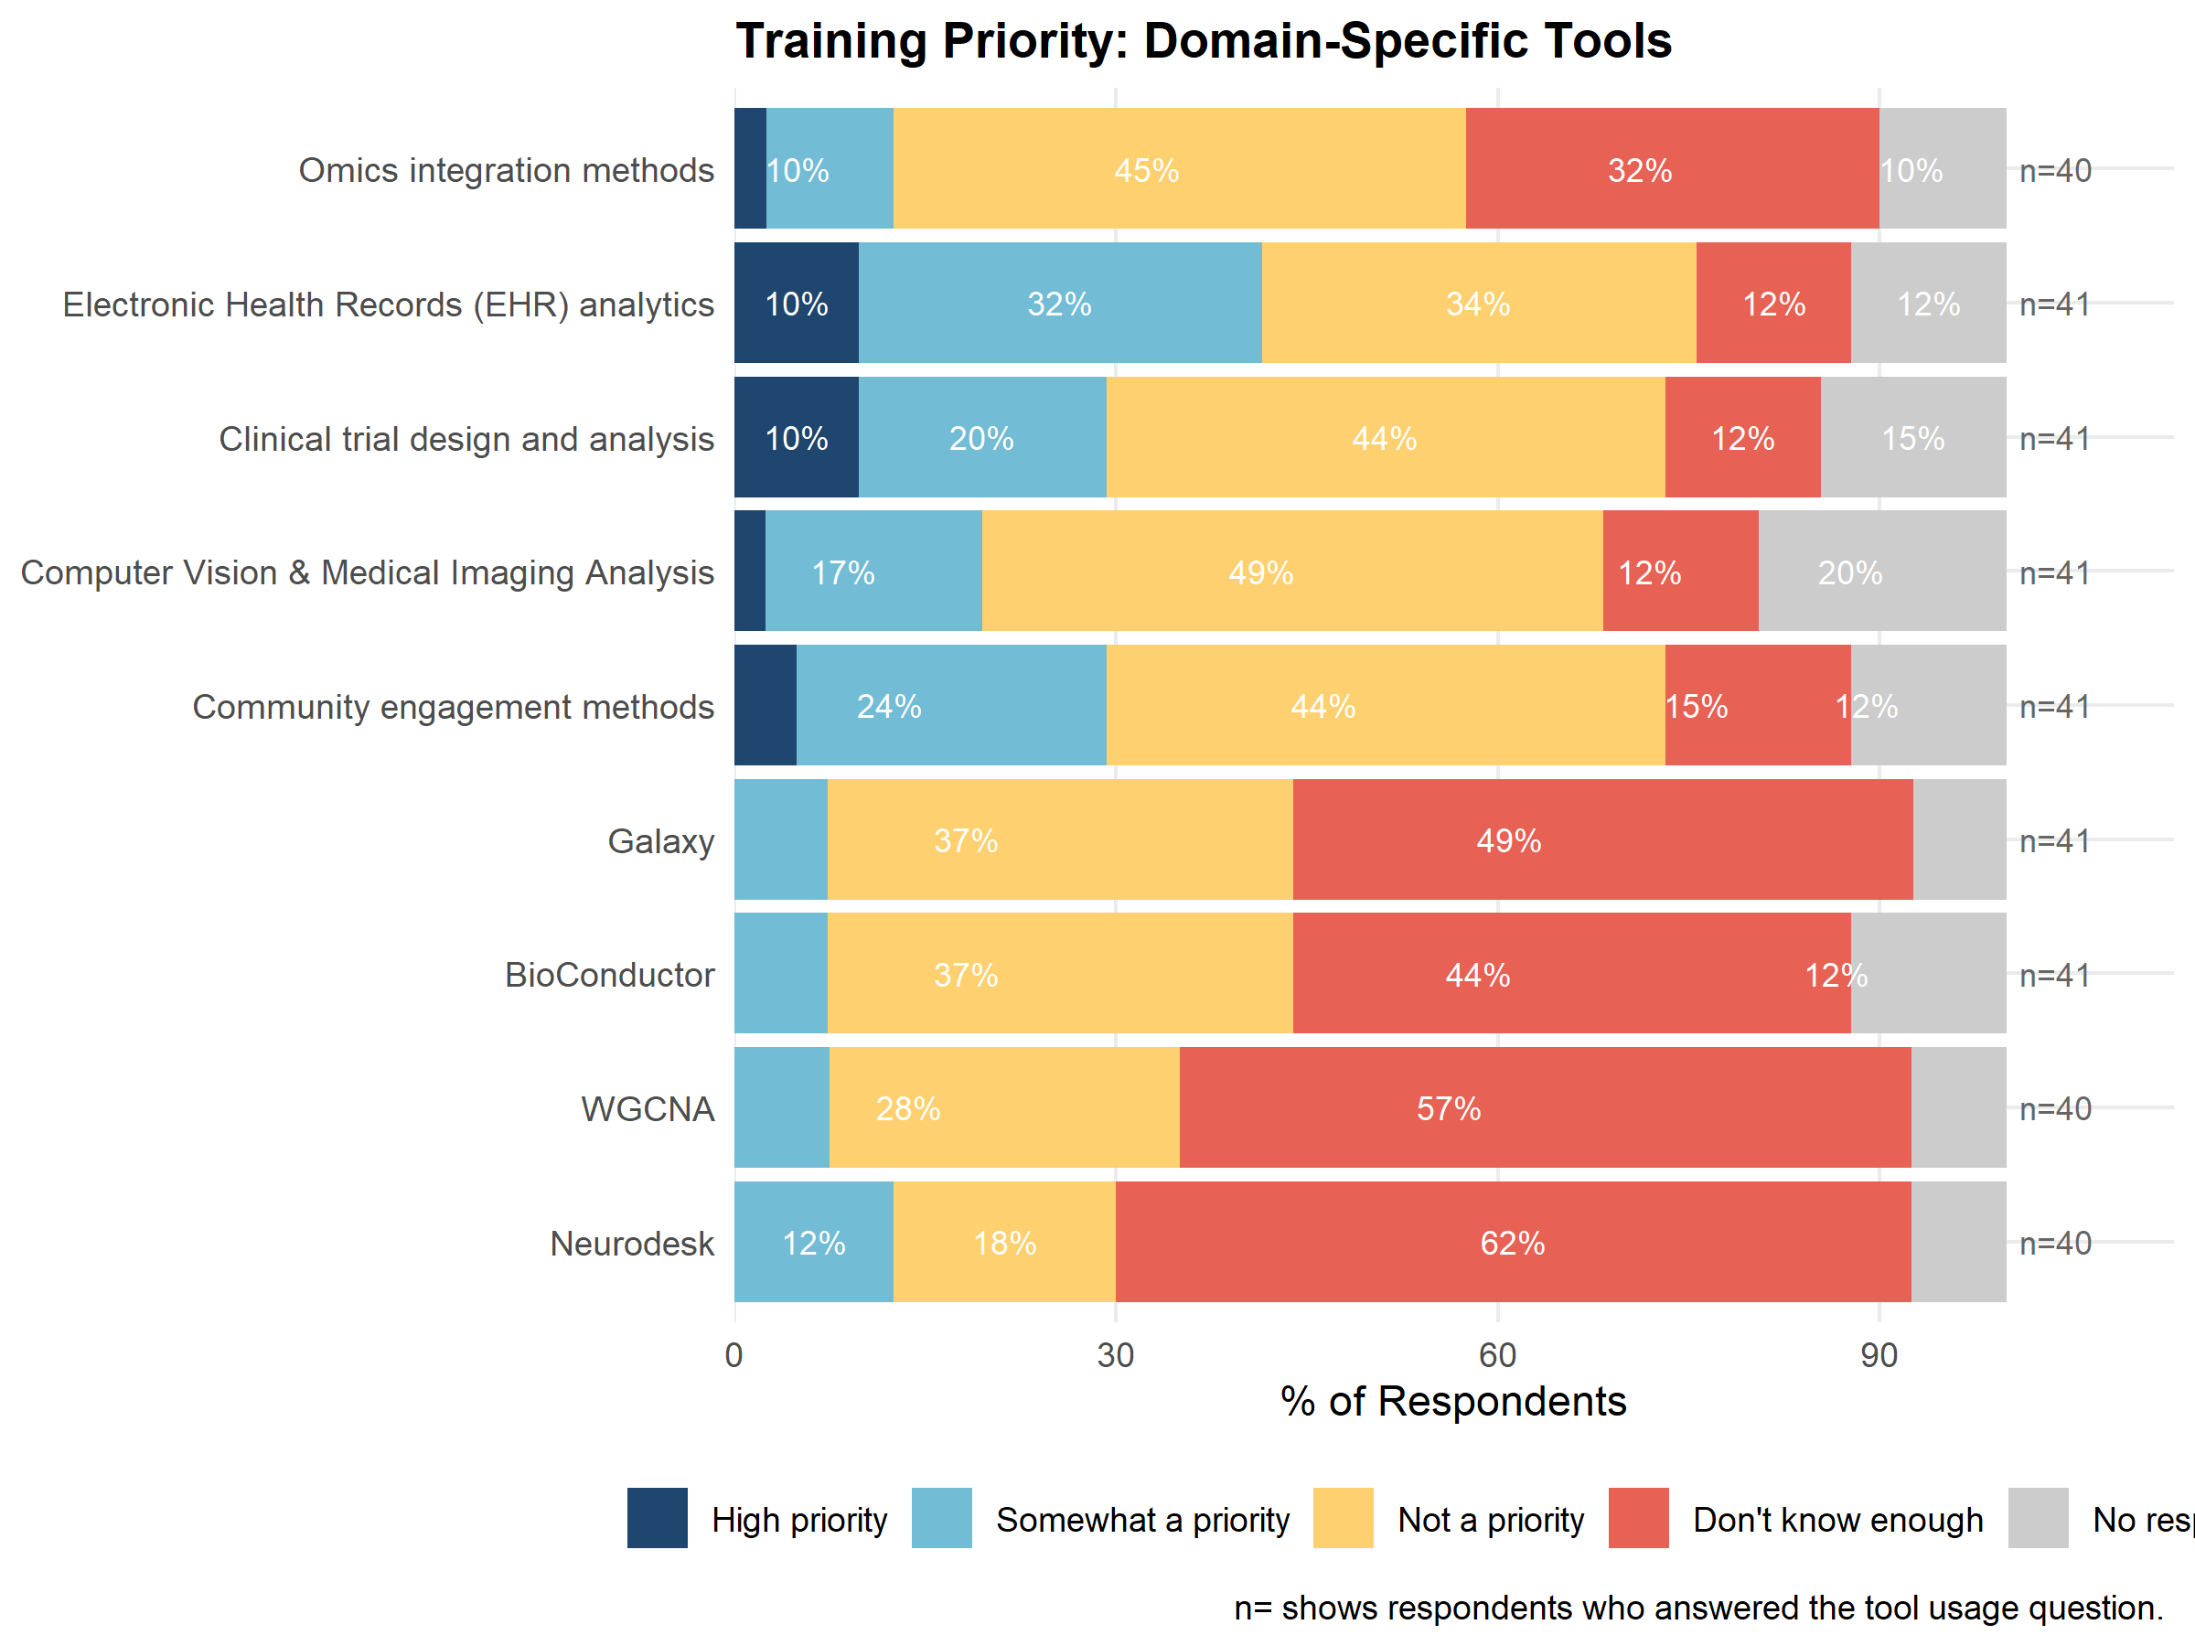
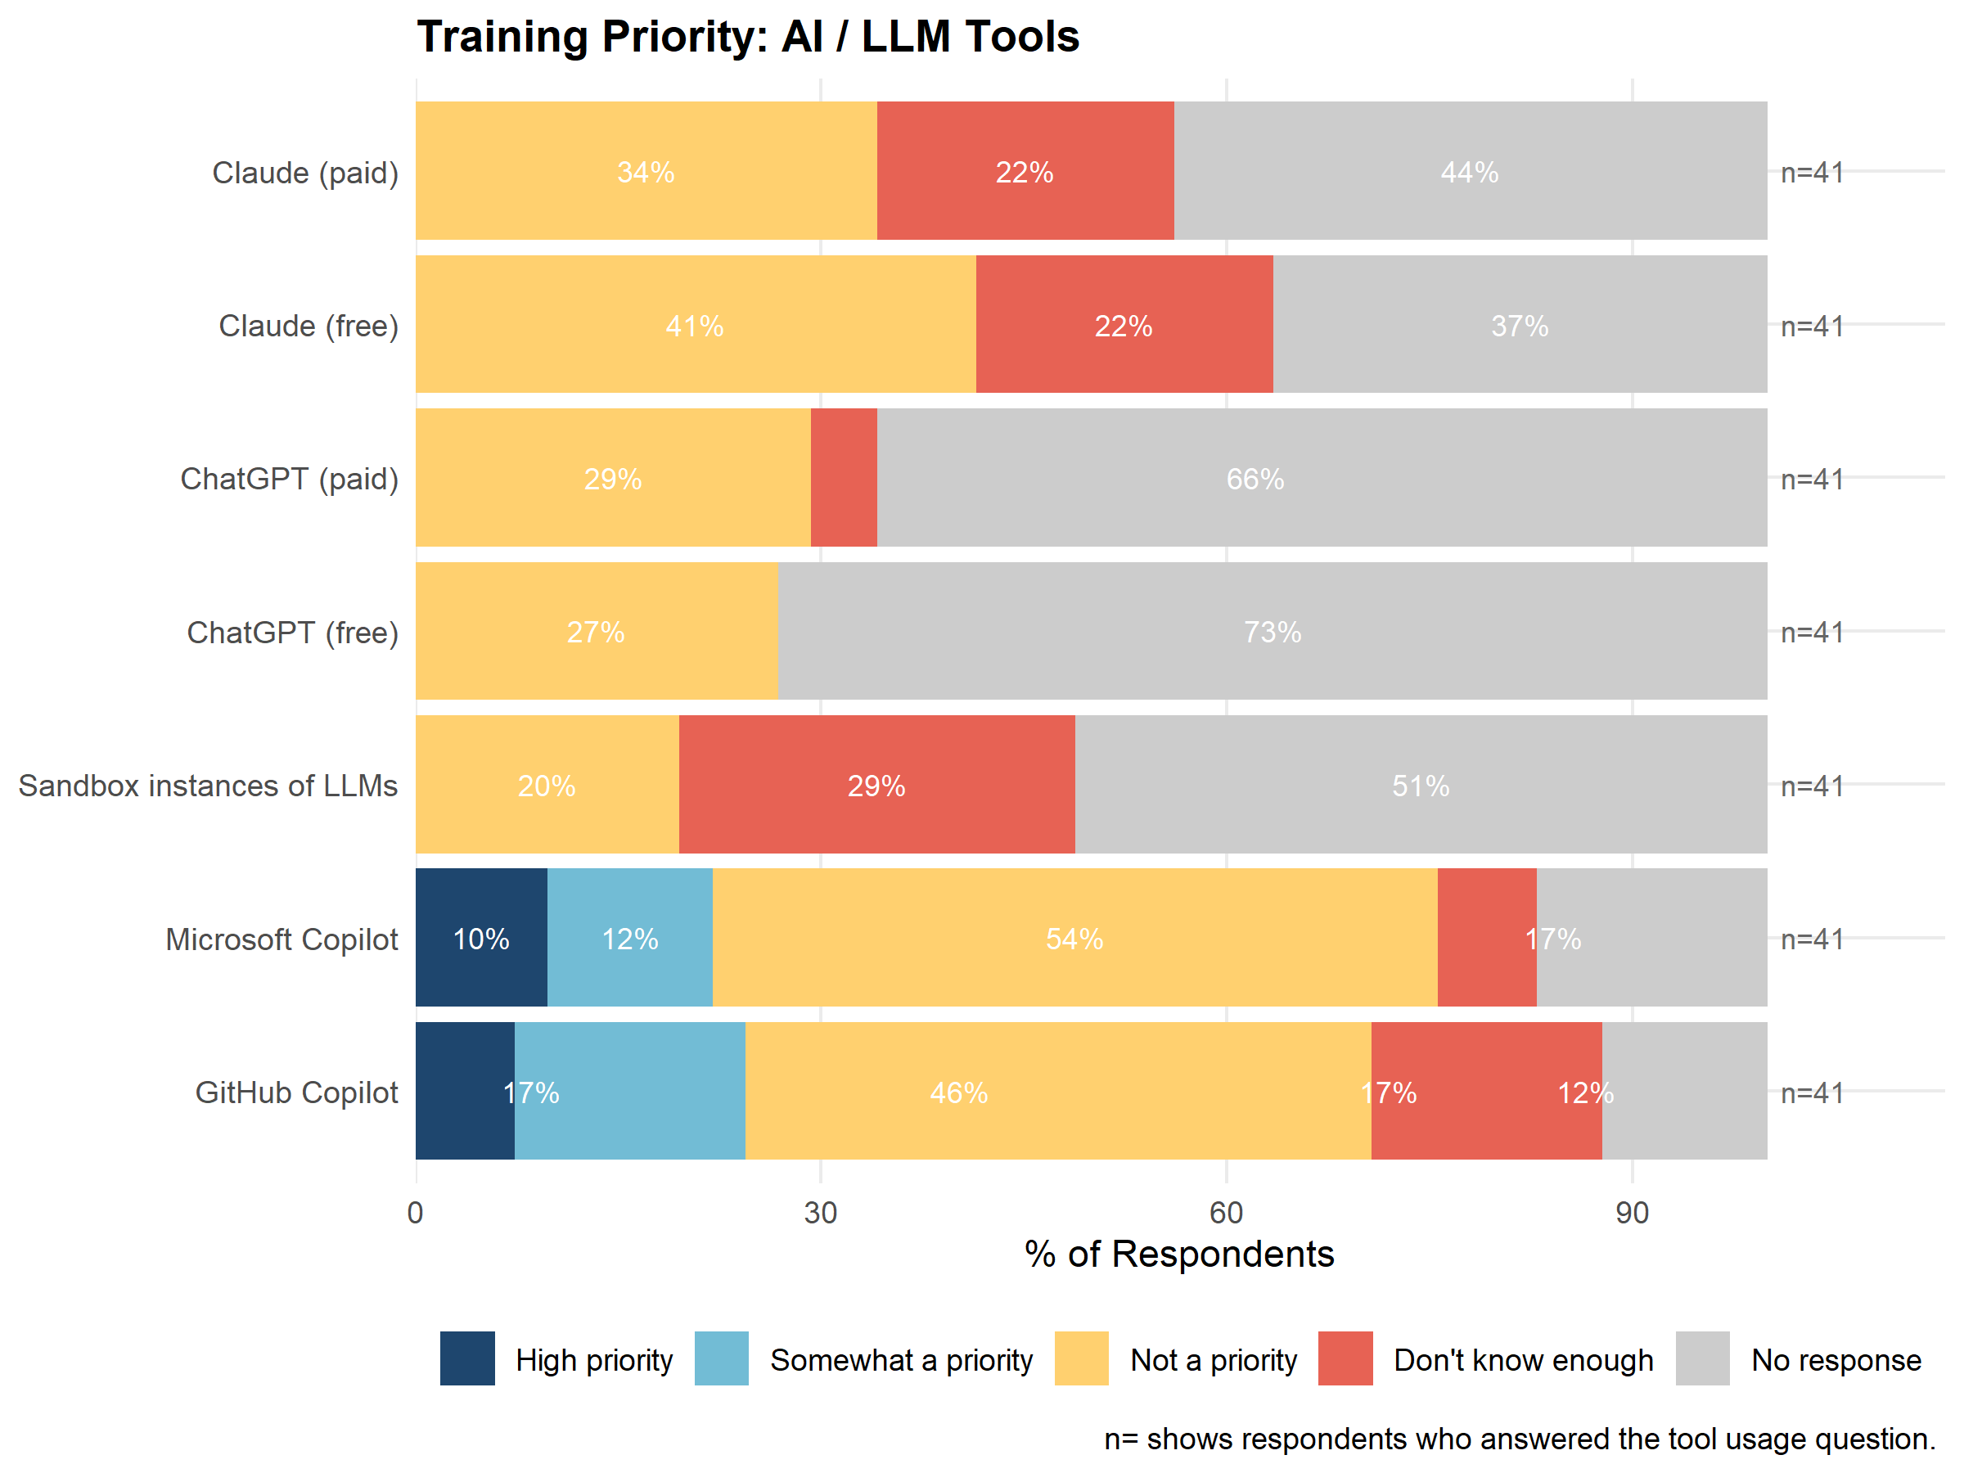
Table 2: Top 10 tools by Training Demand Score.
Tool | Training Demand Score
Electronic Health Records (EHR) analytics | 0.46
R | 0.38
Clinical trial design and analysis | 0.34
SQL & Database management | 0.34
Causal Analysis | 0.33
Community engagement methods | 0.32
GitHub (free) | 0.31
Regression | 0.30
NLP models(BERT, bioBERT, etc) | 0.30
Model interpretability/explainability | 0.30

4.5 Ranking Tools by Training Demand, Training Importance & Training Impact
The table below (Table 3) presents all 57 tools from the survey compiled into one table, with scores for Training Demand, Training Importance, Training Impact, and Total Score (demand + importance + impact). Tools are ranked by total score. Blue cells indicate the top 10 tools for each score.
Tables with the top 10 ranked tools for each score can be seen in Appendix 6.1.
EHR analytics, R, Causal Analysis, Regression, and SQL & Database management were the top 5 ranked tools in terms of total score.
Table 3: All 57 tools ranked by Total Score.
Tool | Training Demand Score | Training Importance Score | Training Impact Score | Total Score
Electronic Health Records (EHR) analytics | 0.46 | 0.34 | 0.31 | 1.12
R | 0.38 | 0.30 | 0.20 | 0.88
Causal Analysis | 0.33 | 0.27 | 0.27 | 0.87
Regression | 0.30 | 0.30 | 0.24 | 0.84
SQL & Database management | 0.34 | 0.25 | 0.19 | 0.78
Clinical trial design and analysis | 0.34 | 0.23 | 0.18 | 0.76
GitHub (free) | 0.31 | 0.24 | 0.19 | 0.74
Clustering or pattern recognition | 0.29 | 0.23 | 0.21 | 0.73
NLP models(BERT, bioBERT, etc) | 0.30 | 0.20 | 0.18 | 0.68
Community engagement methods | 0.32 | 0.18 | 0.15 | 0.64
Python | 0.29 | 0.21 | 0.14 | 0.64
Model interpretability/explainability | 0.30 | 0.19 | 0.13 | 0.62
Deep Learning (CNN, RNN) | 0.26 | 0.18 | 0.17 | 0.61
Bayesian Statistics | 0.23 | 0.19 | 0.17 | 0.59
Microsoft Copilot | 0.27 | 0.17 | 0.11 | 0.55
GitHub Copilot | 0.28 | 0.14 | 0.09 | 0.51
Machine Learning (unsuper./super.) | 0.18 | 0.17 | 0.14 | 0.49
RStudio/Posit (free version) | 0.21 | 0.16 | 0.10 | 0.48
AutoML & Hyperparameter optimisation | 0.26 | 0.13 | 0.08 | 0.47
Synthetic Data & Privacy-Preserving ML | 0.23 | 0.12 | 0.08 | 0.43
Decision Trees/Random Forests | 0.17 | 0.14 | 0.11 | 0.42
Computer Vision & Medical Imaging Analysis | 0.21 | 0.13 | 0.09 | 0.42
Docker or Containers | 0.18 | 0.11 | 0.08 | 0.37
PyTorch | 0.21 | 0.09 | 0.04 | 0.35
Survival analysis/time to event ... | 0.15 | 0.11 | 0.07 | 0.33
Simulation Models: Agent Based Models etc | 0.20 | 0.08 | 0.04 | 0.31
Network analysis | 0.17 | 0.08 | 0.05 | 0.30
TensorFlow | 0.15 | 0.06 | 0.03 | 0.25
VS Code | 0.14 | 0.06 | 0.02 | 0.23
Reinforcement Learning & Adaptive inter. | 0.15 | 0.05 | 0.03 | 0.23
SAS | 0.12 | 0.06 | 0.03 | 0.21
Omics integration methods | 0.14 | 0.05 | 0.02 | 0.21
Gradient boosted (XGBoost, LightGBM) | 0.10 | 0.06 | 0.05 | 0.21
GitHub (paid) | 0.12 | 0.06 | 0.03 | 0.21
Jupyter Notebooks or Hub | 0.10 | 0.06 | 0.03 | 0.19
Julia | 0.14 | 0.03 | 0.01 | 0.18
GitLab | 0.10 | 0.05 | 0.02 | 0.17
RStudio Pro (paid version) | 0.11 | 0.04 | 0.02 | 0.17
Singularity | 0.12 | 0.04 | 0.01 | 0.17
Neurodesk | 0.12 | 0.03 | 0.01 | 0.16
BioConductor | 0.07 | 0.02 | 0.01 | 0.10
Nextflow | 0.07 | 0.02 | 0.00 | 0.09
Low Code No Code Tools in ML | 0.07 | 0.01 | 0.00 | 0.09
WGCNA | 0.07 | 0.01 | 0.00 | 0.09
Galaxy | 0.07 | 0.01 | 0.00 | 0.09
MatLab | 0.05 | 0.02 | 0.01 | 0.07
Snakemake | 0.05 | 0.01 | 0.00 | 0.06
Claude (paid) | 0.00 | 0.00
Claude (free) | 0.00 | 0.00
ChatGPT (paid) | 0.00 | 0.00
ChatGPT (free) | 0.00 | 0.00
Sandbox instances of LLMs | 0.00 | 0.00
Fed. learning models/distr. AI frameworks | 0.00 | 0.00
Graph neural nets & knowledge graphs | 0.00 | 0.00
Power BI | 0.00 | 0.00
Tableau | 0.00 | 0.00
Excel | 0.00 | 0.00

4.6 Training Priority by Skill Level for top 10 tools
Figure 14 shows training priority by skill level for the top 10 tools (ranked by total score). This indicates whether training demand for a given tool is coming mostly from those with no or limited existing skill (suggesting introductory content is needed) or from those who already have some skill but want to deepen it (suggesting more advanced or specialised content is needed).
For most of the top 10 tools, training demand is concentrated among respondents with little or no existing skill. This is most pronounced for Community engagement methods and NLP models, where 91.7% and 90.0% of training demand respectively comes from respondents rating themselves None or Beginner, indicating an almost entirely introductory need. GitHub, Regression, and Clustering or pattern recognition follow a similar pattern, with 73% to 75% of demand from None/Beginner respondents. R is the clear exception: the majority of training demand for R (53.9%) comes from respondents who already rate themselves Intermediate or Advanced, indicating that training for R should prioritise deepening existing skill rather than introducing fundamentals. Electronic Health Records (EHR) analytics sits close to an even split (52.9% None/Beginner, 47.1% Intermediate/Advanced), suggesting training content spanning both introductory and more advanced material would best meet demand for this tool.
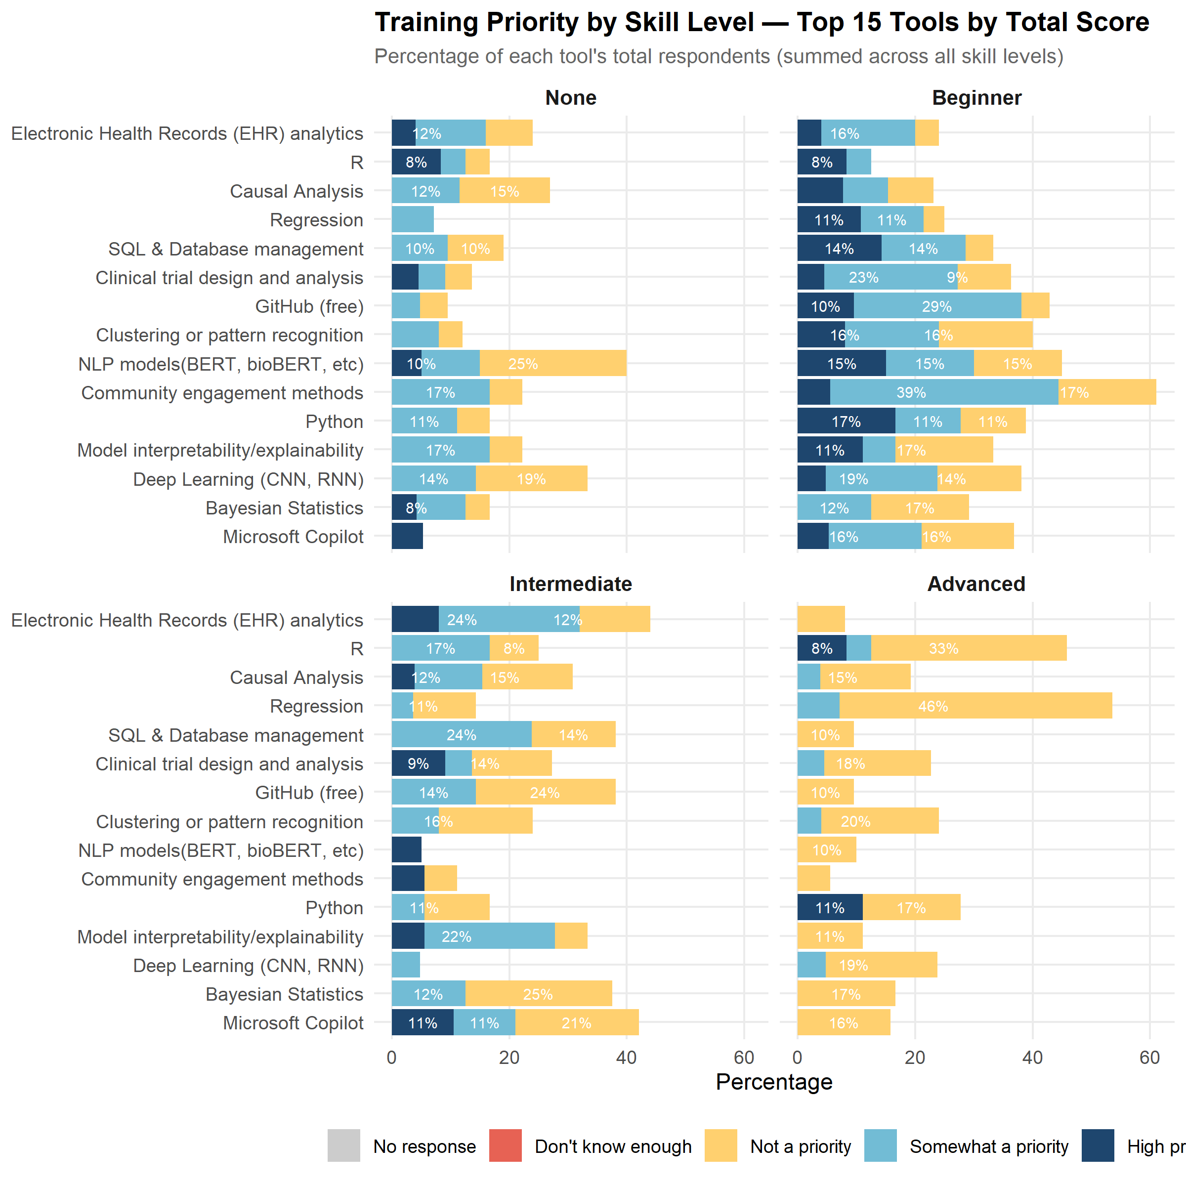
Figure 14: Training priority by skill level, for the top 10 tools (by total score).

4.7 How Does the Community Want to Learn?
Learning preferences were diverse across respondents. While there were some clear preferences for formats and time commitment required when it comes to how health researchers prefer to learn, it is clear that the audience is diverse, and there is no clear format or learning approach that will suit all learners, with the exception of semester-long courses, which showed the lowest preference. Unsurprisingly, time availability is the primary limiting factor when engaging with training. Motivation for engaging in training is predominantly around the development of their own learning and the skills required to do their current or future work. The results also show minimal importance given to formal certification, CPD credits or access to compute as motivators.
Learning Preferences
Video tutorials, one-on-one mentoring and self-paced online courses were the most preferred formats overall, while hands-on projects and conference workshops were the least preferred (see Preferred Learning Formats, below, for detail).
Motivation, Time Commitments Preferences
Respondents were motivated to participate in training across a broad range of factors. The top 3 motivators for engaging in training were: ‘Develop new skills required for a specific research project’ (77%), ‘Develop additional skills (e.g. to apply for promotion, funding etc)’ (65%) and ‘Keep up with expectations of my current role’ (55%).
In terms of time commitments, short courses (1-2 hours single topic) and half-day workshops (3-4 hours) were the preferred time commitment (97% and 94% respectively, somewhat and most preferred combined).
Certification & Barriers
Formal certification and CPD credits are, at best, modest motivators for training participation (see Importance of Training Incentives, below). Respondents foremost are motivated by advancing their ability to execute the analytics essential to their research.
Time availability is the dominant barrier to training participation (see Barriers to Training Participation, below), reinforcing the need for flexible, asynchronous formats and underscoring the value of the database and training discovery tool detailed in Work Package 6.4 and 6.5.
Respondents highlighted that “Courses of interest are not offered very often” and “Application of content to active projects” were also barriers.

4.7.1 Preferred Learning Formats
Respondents rated 12 learning formats on a three-point preference scale, Most preferred, Somewhat preferred and Not preferred at all. One-on-one mentoring, self-paced online courses, and video tutorials were the most preferred learning formats (Figure 15). Interestingly, hands-on projects and conference workshops were the least preferred (52% and 39% indicated not preferred at all, respectively).
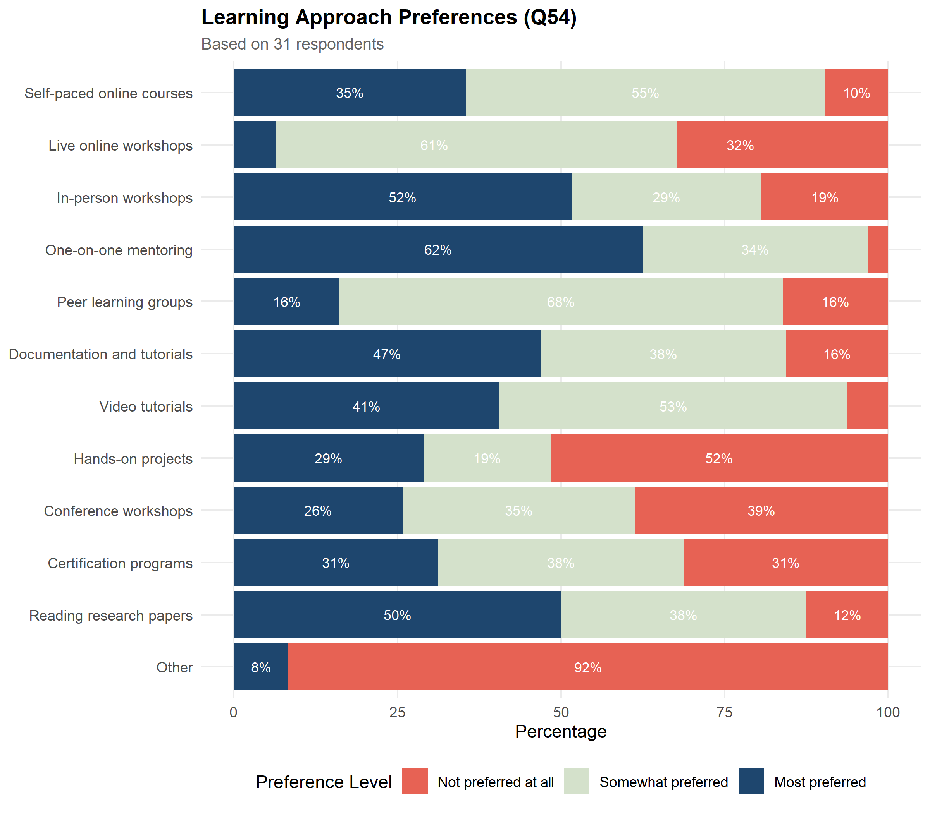
Figure 15: Preferences across 12 learning delivery formats (Q54).

4.7.2 Preferred Time Commitment
Respondents rated nine time commitment options. Short, flexible formats are strongly preferred over intensive multi-day or semester-length commitments. Respondents highlighted through survey open text questions that preferred time commitment depends on the complexity of the content.
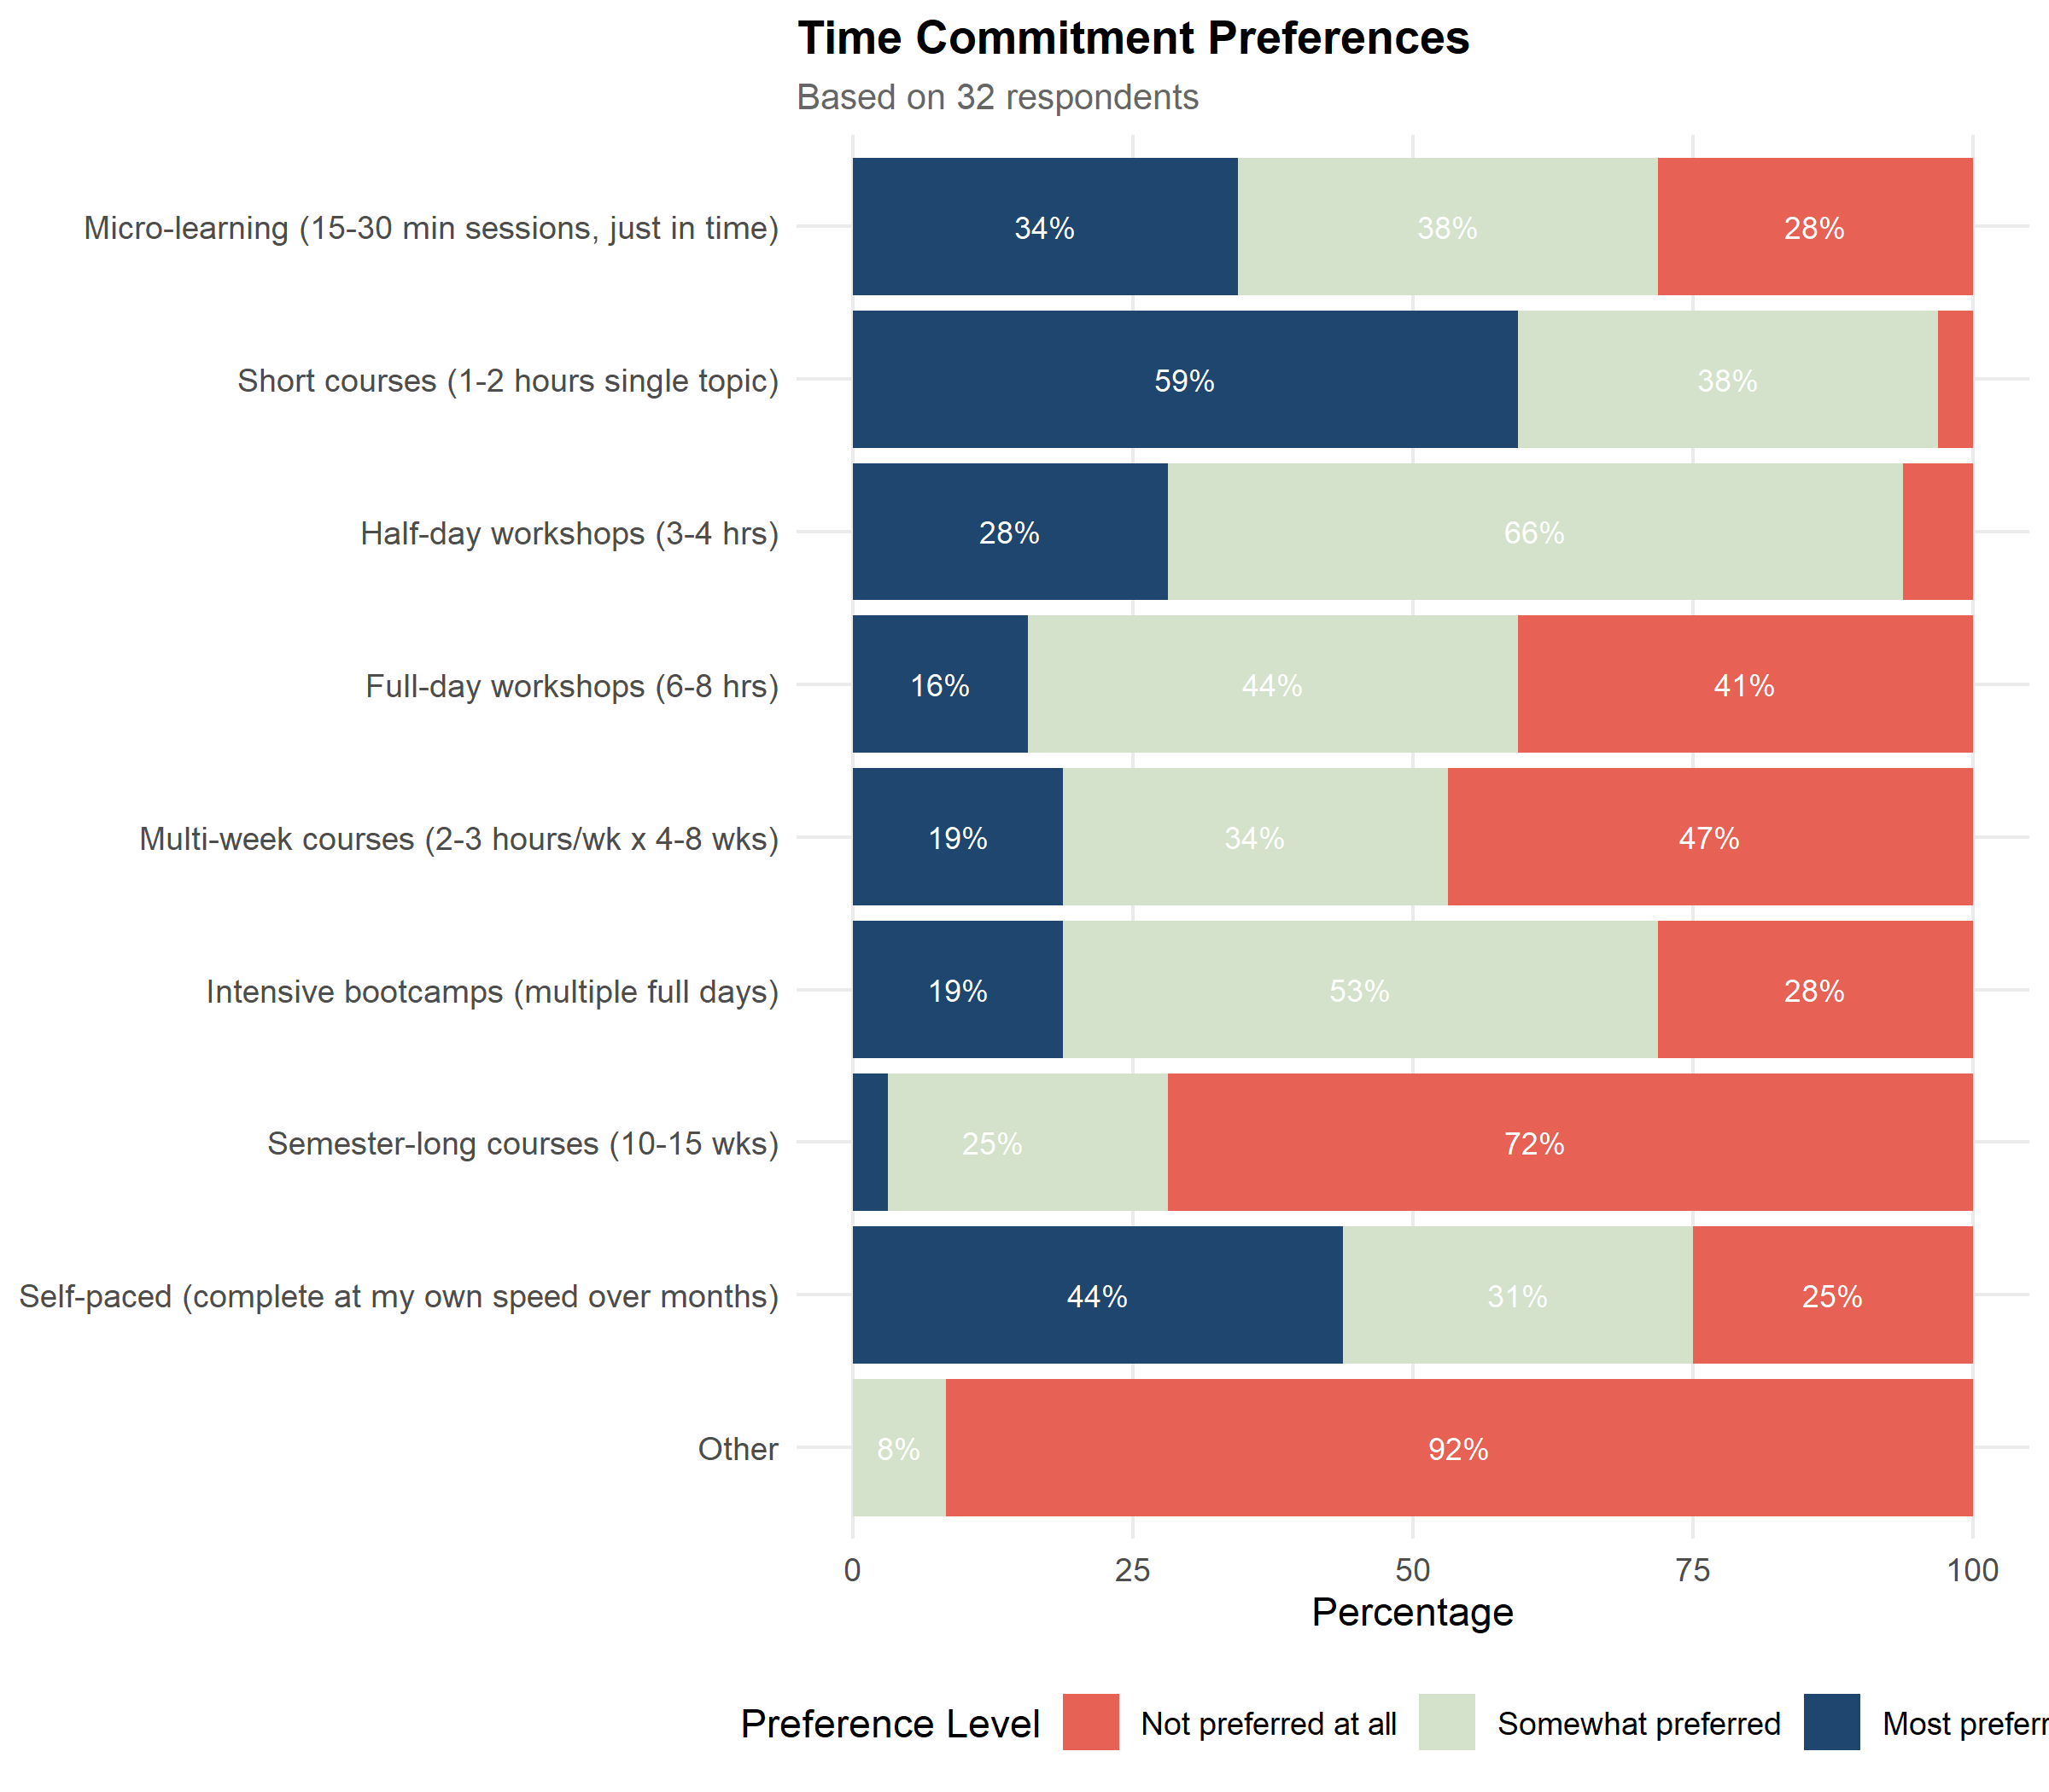
Figure 16: Preferences across nine time commitment formats.

4.7.3 Barriers to Training Participation
Time availability is the dominant barrier to training participation, ahead of all others, followed by cost/licensing and awareness of quality training. This reinforces the need for flexible, asynchronous formats, and indicates the importance of employer support. Awareness of quality training also supports the case for the database and training discovery tool detailed in Work Package 6.4 and 6.5.
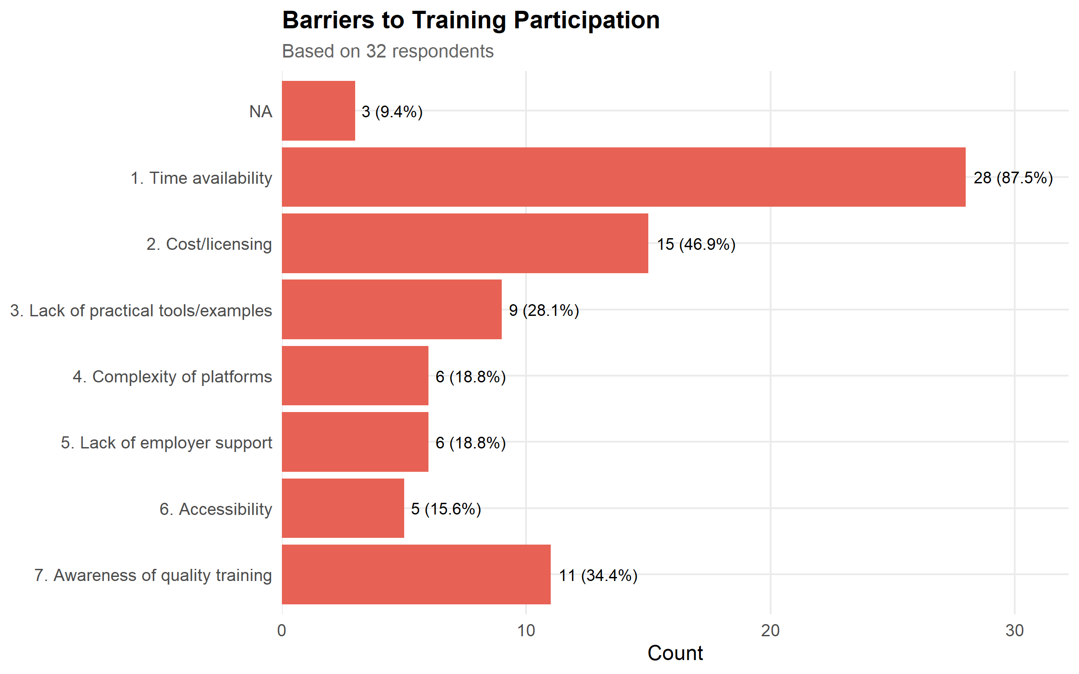
Figure 17: Barriers to training participation (multiple responses permitted).
Respondents also highlighted the following additional barriers to engaging in training:
- “Courses of interest are not offered very often.”
- “I train and teach and the quality of digital health training is very poor and experts are not recognised.”
- “Application of content to active projects.”

4.7.4 Importance of Training Incentives
Respondents rated four training incentives: ‘formal certification’, ‘CPD credits’, ‘priority access to compute resources’, and ‘other’. All incentives were relatively equal, close to half of respondents rated each not a motivator, with only around one in five rating each highly motivating. Incentives are not the primary driver of training participation.
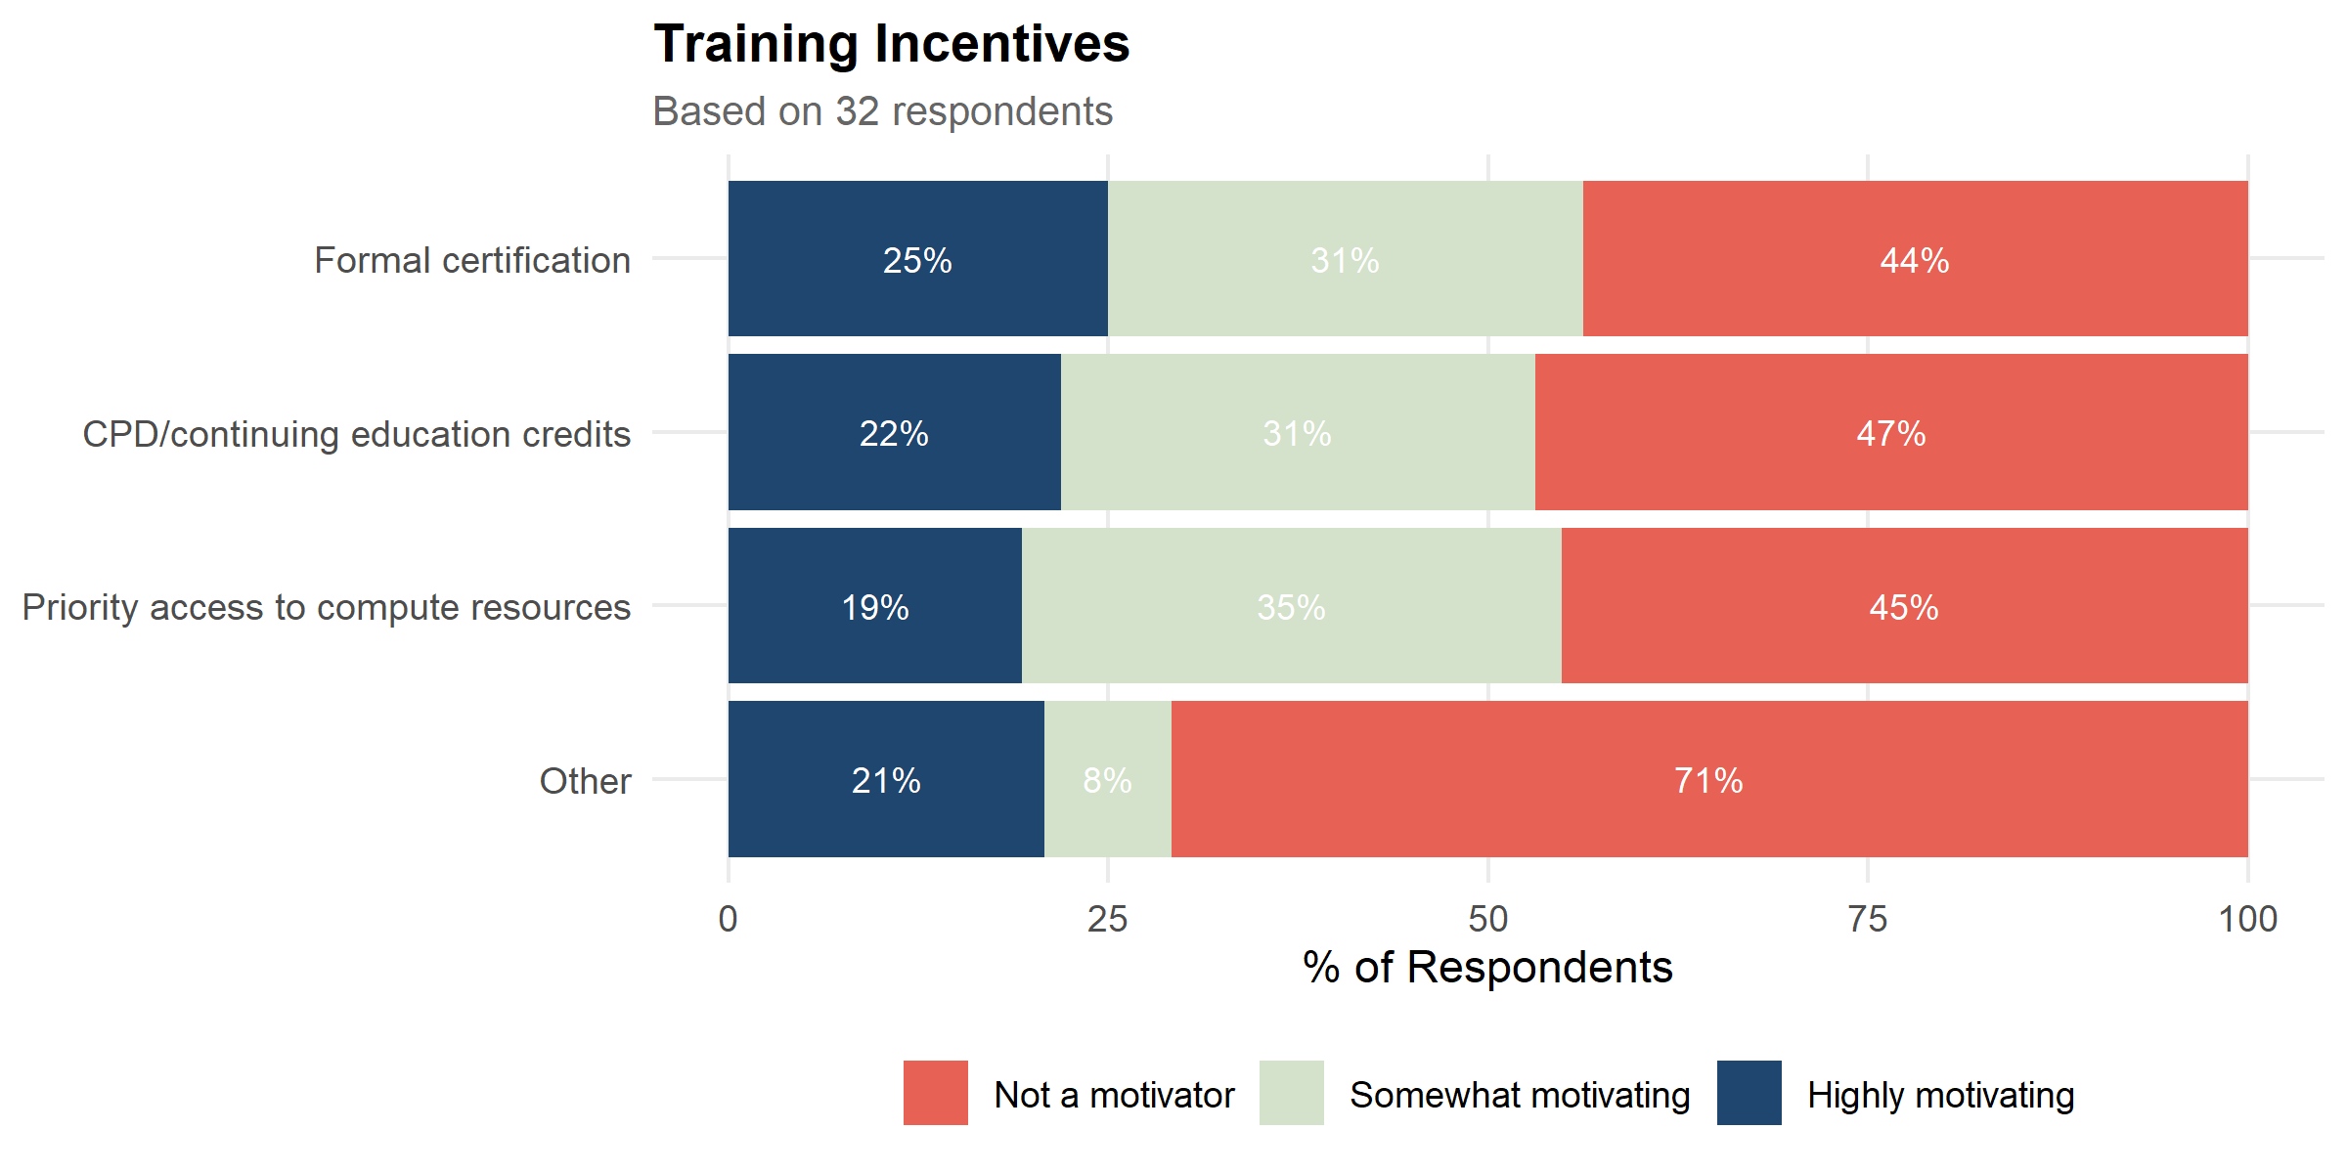
Figure 18: Rated importance of training incentives.
Respondents listed the following additional training incentives:
- Project-specific learning
- Quality practical learning from real experts not just people who’ve read some publications.
- if the topic is relevant, I will do it regardless of any other factors.
- Support my team
- Quality and applicability to needs.

4.7.5 Motivations for Training
Respondents were asked to select the top 3 motivations for engaging in future training.
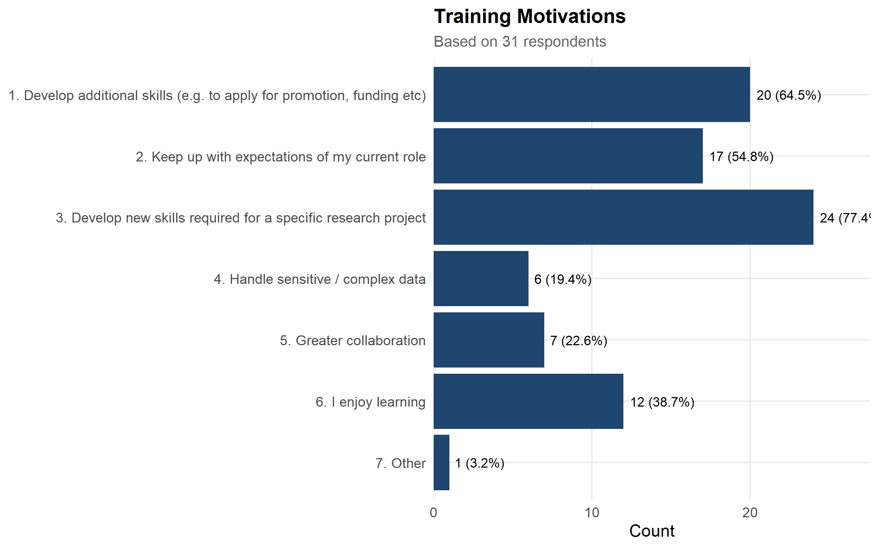
Figure 19: Motivations for engaging in training (multiple responses permitted).
The single “Other” response was: “Support my team.”

5 Insights & Recommendations

5.0.1 Tool Training Priorities
Electronic Health Records (EHR) analytics, R, Causal Analysis, Regression, and SQL & Database management were the top 5 ranked tools when in terms of total score (Training Demand + Training Importance + Training Impact Table 3). EHR analytics ranks first overall, and its score is driven mainly by its Training Impact Score, the highest of any tool surveyed. Since Training Impact combines tool demand with the size of the existing skill gap, this indicates that EHR analytics is both an area of strong interest and one where current skill levels lag well behind that interest, making it a high-value target for the resource hub’s first wave of training content.
More broadly, the top 10 tools span a mix of categories: general-purpose programming and analysis tools (R, SQL, GitHub, Causal Analysis, Regression, Clustering or pattern recognition, NLP models), and domain-specific health analytics tools (EHR analytics, Clinical trial design and analysis, and Community engagement methods). This suggests that training priorities should not be limited to foundational data science skills alone; but there is significant demand for health research specific tools and methods such as EHR analytics, clinical trial design, and community engagement methods, show comparable or greater training demand and impact.

5.0.2 From Priorities to Training Resources
The tool list and rankings presented above provide the basis for Work Package 6.2, which matches each of these training priorities against training resources already available online. The recommended shortlist for this matching process is given in Table 4 (see Notable Anomalies, below), which corrects for a small number of tools whose Total Score could not be calculated.

5.0.3 Learning Format & Time Commitment Implications
The community’s preferences point clearly toward short, flexible, and personalised training delivery. One-on-one mentoring, self-paced online courses, and video tutorials were consistently the most preferred formats, while hands-on projects and conference workshops were the least preferred. Similarly, short courses (1–2 hours) and half-day workshops (3–4 hours) were strongly preferred time commitments, while semester-long courses (10–15 weeks) were the least preferred of any option offered.
For the resource hub, this suggests that training content is likely to have greater reach and impact if it is delivered in short, modular, self-paced or mentored formats rather than as extended courses or one-off conference-style sessions.

5.0.4 Notable Anomalies
Excel and a subset of AI/LLM tools returned NA values for Training Importance Score, Training Impact Score, and Total Score. This is because the survey’s skill level and training priority follow-up questions (Q47–Q50) were inadvertently omitted in the skill and training priority questions when the survey was constructed. This is a survey design omission rather than a reflection of genuine absence of training need.
The full list of affected tools is as follows:
Tools omitted from the skill and training priority follow-up questions:
From Q24 (Programming & Environments), omitted from Q47:
- Power BI
- Tableau
- Excel
From Q27 (Analysis Methods), none omitted: None omitted
**From Q30 (Domain-Specific Tools):* None omitted
From Q33 (AI / LLM Tools), omitted from Q50:
- Claude (paid)
- Claude (free)
- ChatGPT (paid)
- ChatGPT (free)
- Sandbox instances of LLMs
Q33 tools correctly included in Q50 (not affected):
- Microsoft Copilot
- GitHub Copilot
To account for this, the shortlist of tools carried forward to Work Package 6.2 and 6.3 has been constructed as the union of the top 10 tools by Total Score and the top 10 tools by Training Demand Score (Table 4), with duplicates removed. This ensures that tools with high demonstrated demand are not silently excluded from WP6.2 simply because they were erroneously dropped in the skills and training priority questions.
Table 4 below is the recommended tool shortlist for Work Package 6.2 - Database 2: tools shaded under Training Demand Score were recovered via demand alone (i.e. their Total Score could not be calculated for the reasons set out above), and are flagged here for transparency.
Table 4: Top tools shortlist: union of top 10 by Training Demand and top 10 by Total Score.
Tool | Training Demand Score | Training Importance Score | Training Impact Score | Total Score
Electronic Health Records (EHR) analytics | 0.46 | 0.34 | 0.31 | 1.12
R | 0.38 | 0.30 | 0.20 | 0.88
Causal Analysis | 0.33 | 0.27 | 0.27 | 0.87
Regression | 0.30 | 0.30 | 0.24 | 0.84
SQL & Database management | 0.34 | 0.25 | 0.19 | 0.78
Clinical trial design and analysis | 0.34 | 0.23 | 0.18 | 0.76
GitHub (free) | 0.31 | 0.24 | 0.19 | 0.74
Clustering or pattern recognition | 0.29 | 0.23 | 0.21 | 0.73
NLP models(BERT, bioBERT, etc) | 0.30 | 0.20 | 0.18 | 0.68
Community engagement methods | 0.32 | 0.18 | 0.15 | 0.64
Model interpretability/explainability | 0.30 | 0.19 | 0.13 | 0.62

5.0.5 Looking Forward
The list of 57 tools assessed in this survey does not capture every tool relevant to the community. Open-text responses identified several additional tools not captured; Stata was the most frequently mentioned (5 mentions), and we acknowledge that it should have been included in the initial survey tool list. For this reason it will also be carried forward to Workpackage 6.2.
The pace of change in AI/LLM tooling is a further consideration. Since this survey was developed, the range of LLM-based tools available to researchers has continued to grow at a rapid rate, and several newer tools (e.g. Google Gemini, Perplexity, NotebookLM) were already being mentioned by respondents.

6 Conclusion
This report has presented the findings of Work Package 6.1, which sought to characterise the learning needs of the Australian health research community in advanced analytics and AI tools. Drawing on survey responses from 99 respondents across 57 tools and methods, the survey found that training demand is diverse, with some interest present across nearly every tool surveyed, but is most concentrated in Electronic Health Records (EHR) analytics, R, Causal Analysis, Regression, and SQL & Database management. EHR analytics stands out in particular, ranking first overall on the strength of both strong demand and a substantial existing skill gap.
The survey also found clear preferences in how the community wants to learn: short, flexible, and personalised formats, such as one-on-one mentoring, self-paced online courses, and short courses, were consistently preferred over extended courses or conference-style sessions, and time availability was the dominant barrier to participation. Structured incentives such as certification and CPD credits were found to play, at most, a modest role in motivating training uptake, with most respondents instead motivated by the direct relevance of training to their current or future work.
Together, these findings provide a tool-by-tool ranking of training need and a clear picture of the formats and conditions under which the community is most likely to engage. The recommended tool shortlist for Work Package 6.2 (Table 4) reflects this ranking. This shortlist, together with the community’s stated learning preferences, will directly inform the design of the training resource search protocol in Work Packages 6.2 and 6.3, and the course discovery prototypes in Work Package 6.4.

7 Appendix

7.1 Top 10 tools for Demand, Importance & Impact
Table 5: Top 10 tools by Training Demand Score.
Tool | Training Demand Score
Electronic Health Records (EHR) analytics | 0.46
R | 0.38
Clinical trial design and analysis | 0.34
SQL & Database management | 0.34
Causal Analysis | 0.33
Community engagement methods | 0.32
GitHub (free) | 0.31
Regression | 0.30
NLP models(BERT, bioBERT, etc) | 0.30
Model interpretability/explainability | 0.30

Table 6: Top 10 tools by Importance Score.
Tool | Importance Score
Electronic Health Records (EHR) analytics | 0.34
R | 0.30
Regression | 0.30
Causal Analysis | 0.27
SQL & Database management | 0.25
GitHub (free) | 0.24
Clinical trial design and analysis | 0.23
Clustering or pattern recognition | 0.23
Python | 0.21
NLP models(BERT, bioBERT, etc) | 0.20

Table 7: Top 10 tools by Impact Score.
Tool | Training Impact Score
Electronic Health Records (EHR) analytics | 0.31
Causal Analysis | 0.27
Regression | 0.24
Clustering or pattern recognition | 0.21
R | 0.20
SQL & Database management | 0.19
GitHub (free) | 0.19
Clinical trial design and analysis | 0.18
NLP models(BERT, bioBERT, etc) | 0.18
Deep Learning (CNN, RNN) | 0.17

7.2 Training Priority by Skill Level (all tools)
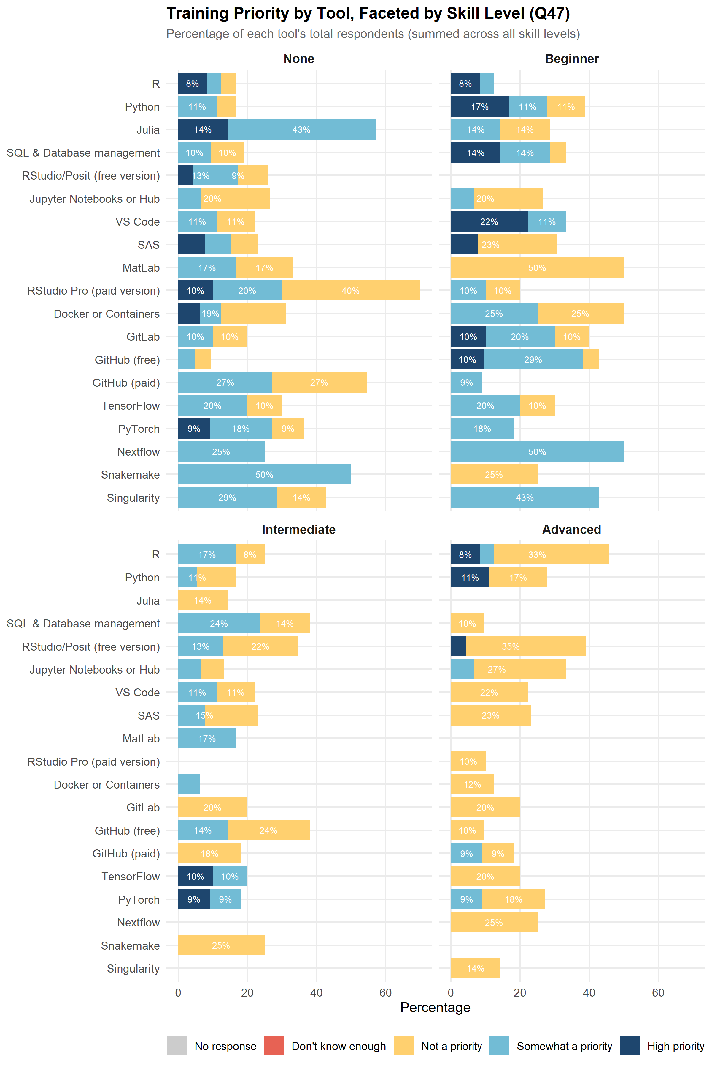
Figure 20: Training priority by tool, faceted by current skill level: programming languages, IDEs, and data science platforms (Q47).

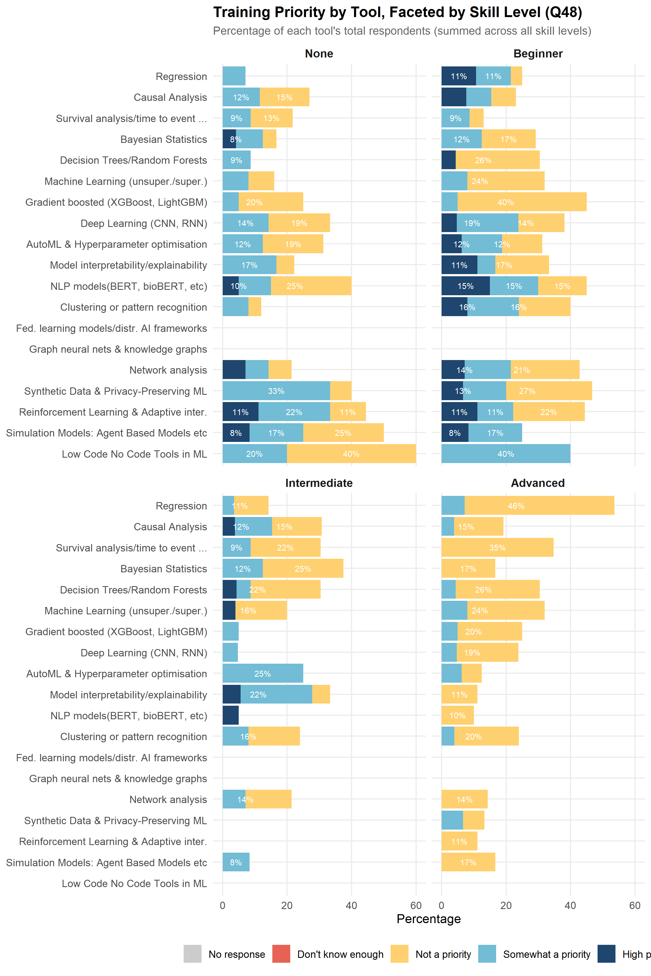
Figure 21: Training priority by tool, faceted by current skill level: statistical and machine learning methods (Q48).

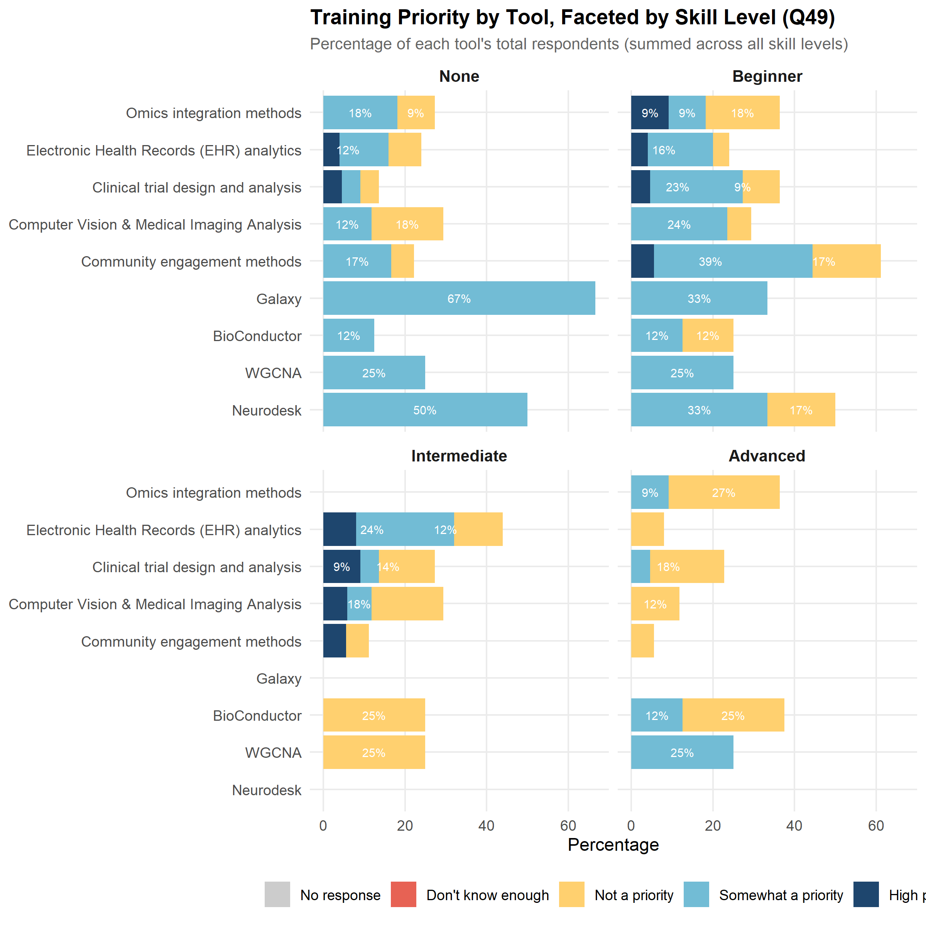
Figure 22: Training priority by tool, faceted by current skill level: domain-specific health analytics tools (Q49).

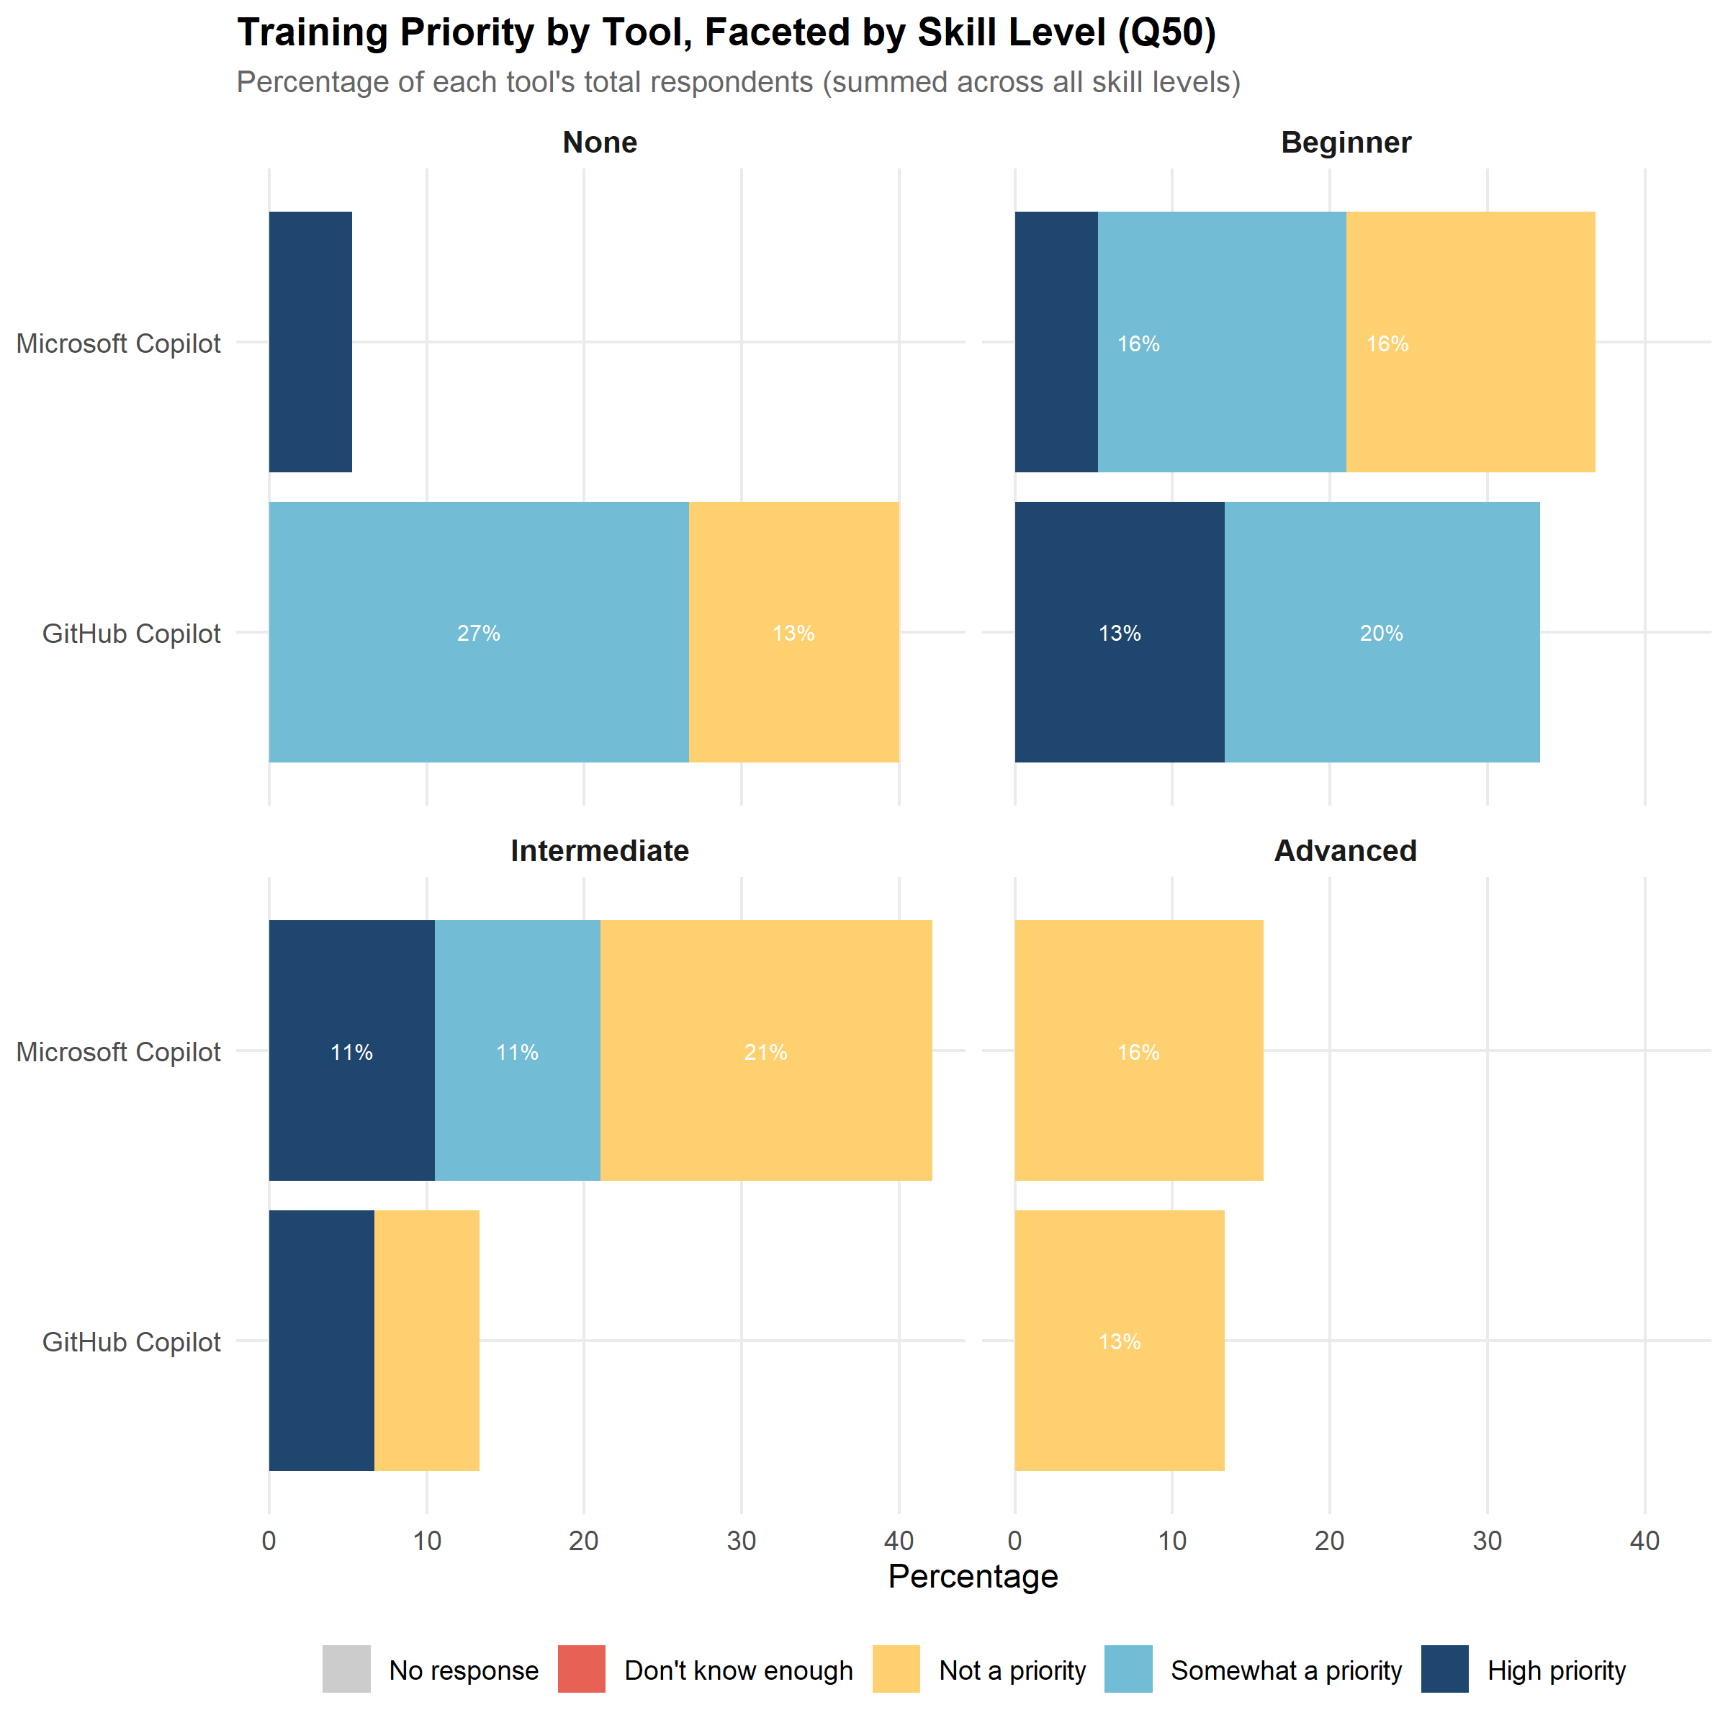
Figure 23: Training priority by tool, faceted by current skill level: AI and LLM tools (Q50).

7.3 Training Demand vs Current Use
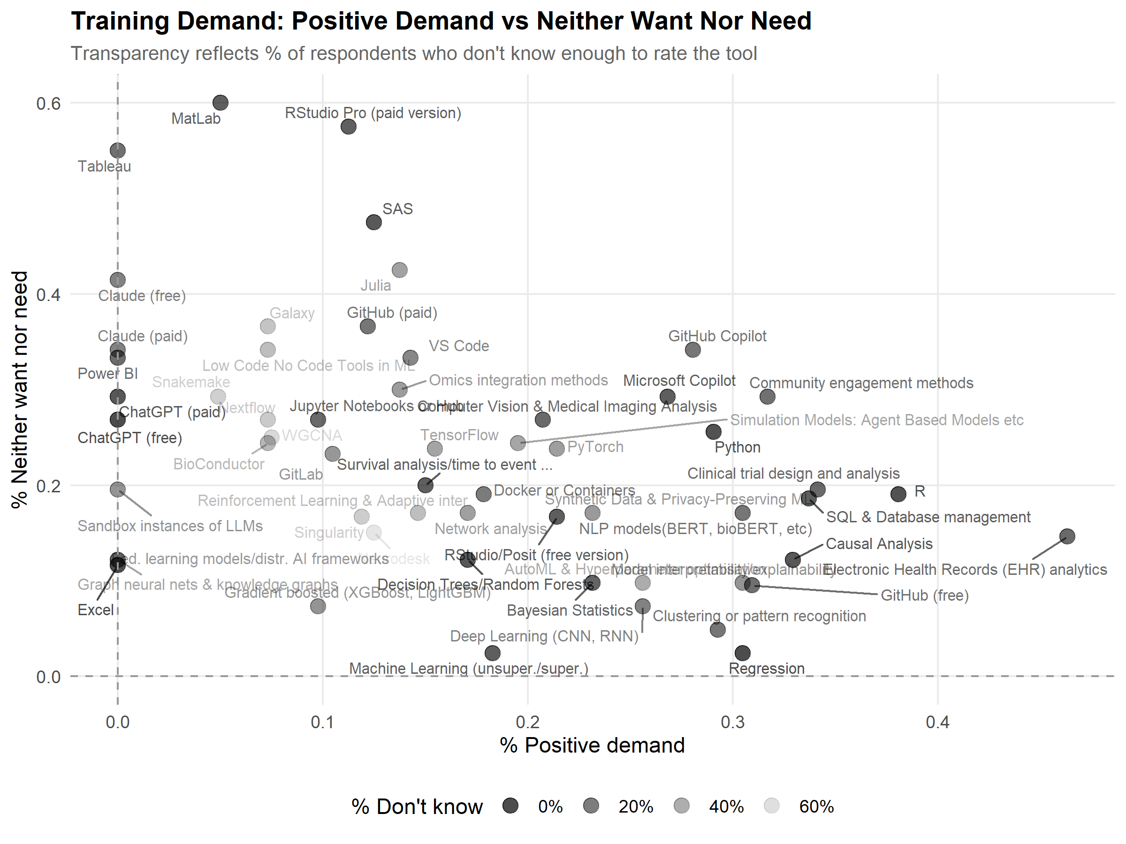
Figure 24: Training demand: positive demand vs neither want nor need.

7.4 Heatmap of Demand, Importance and Impact Scores
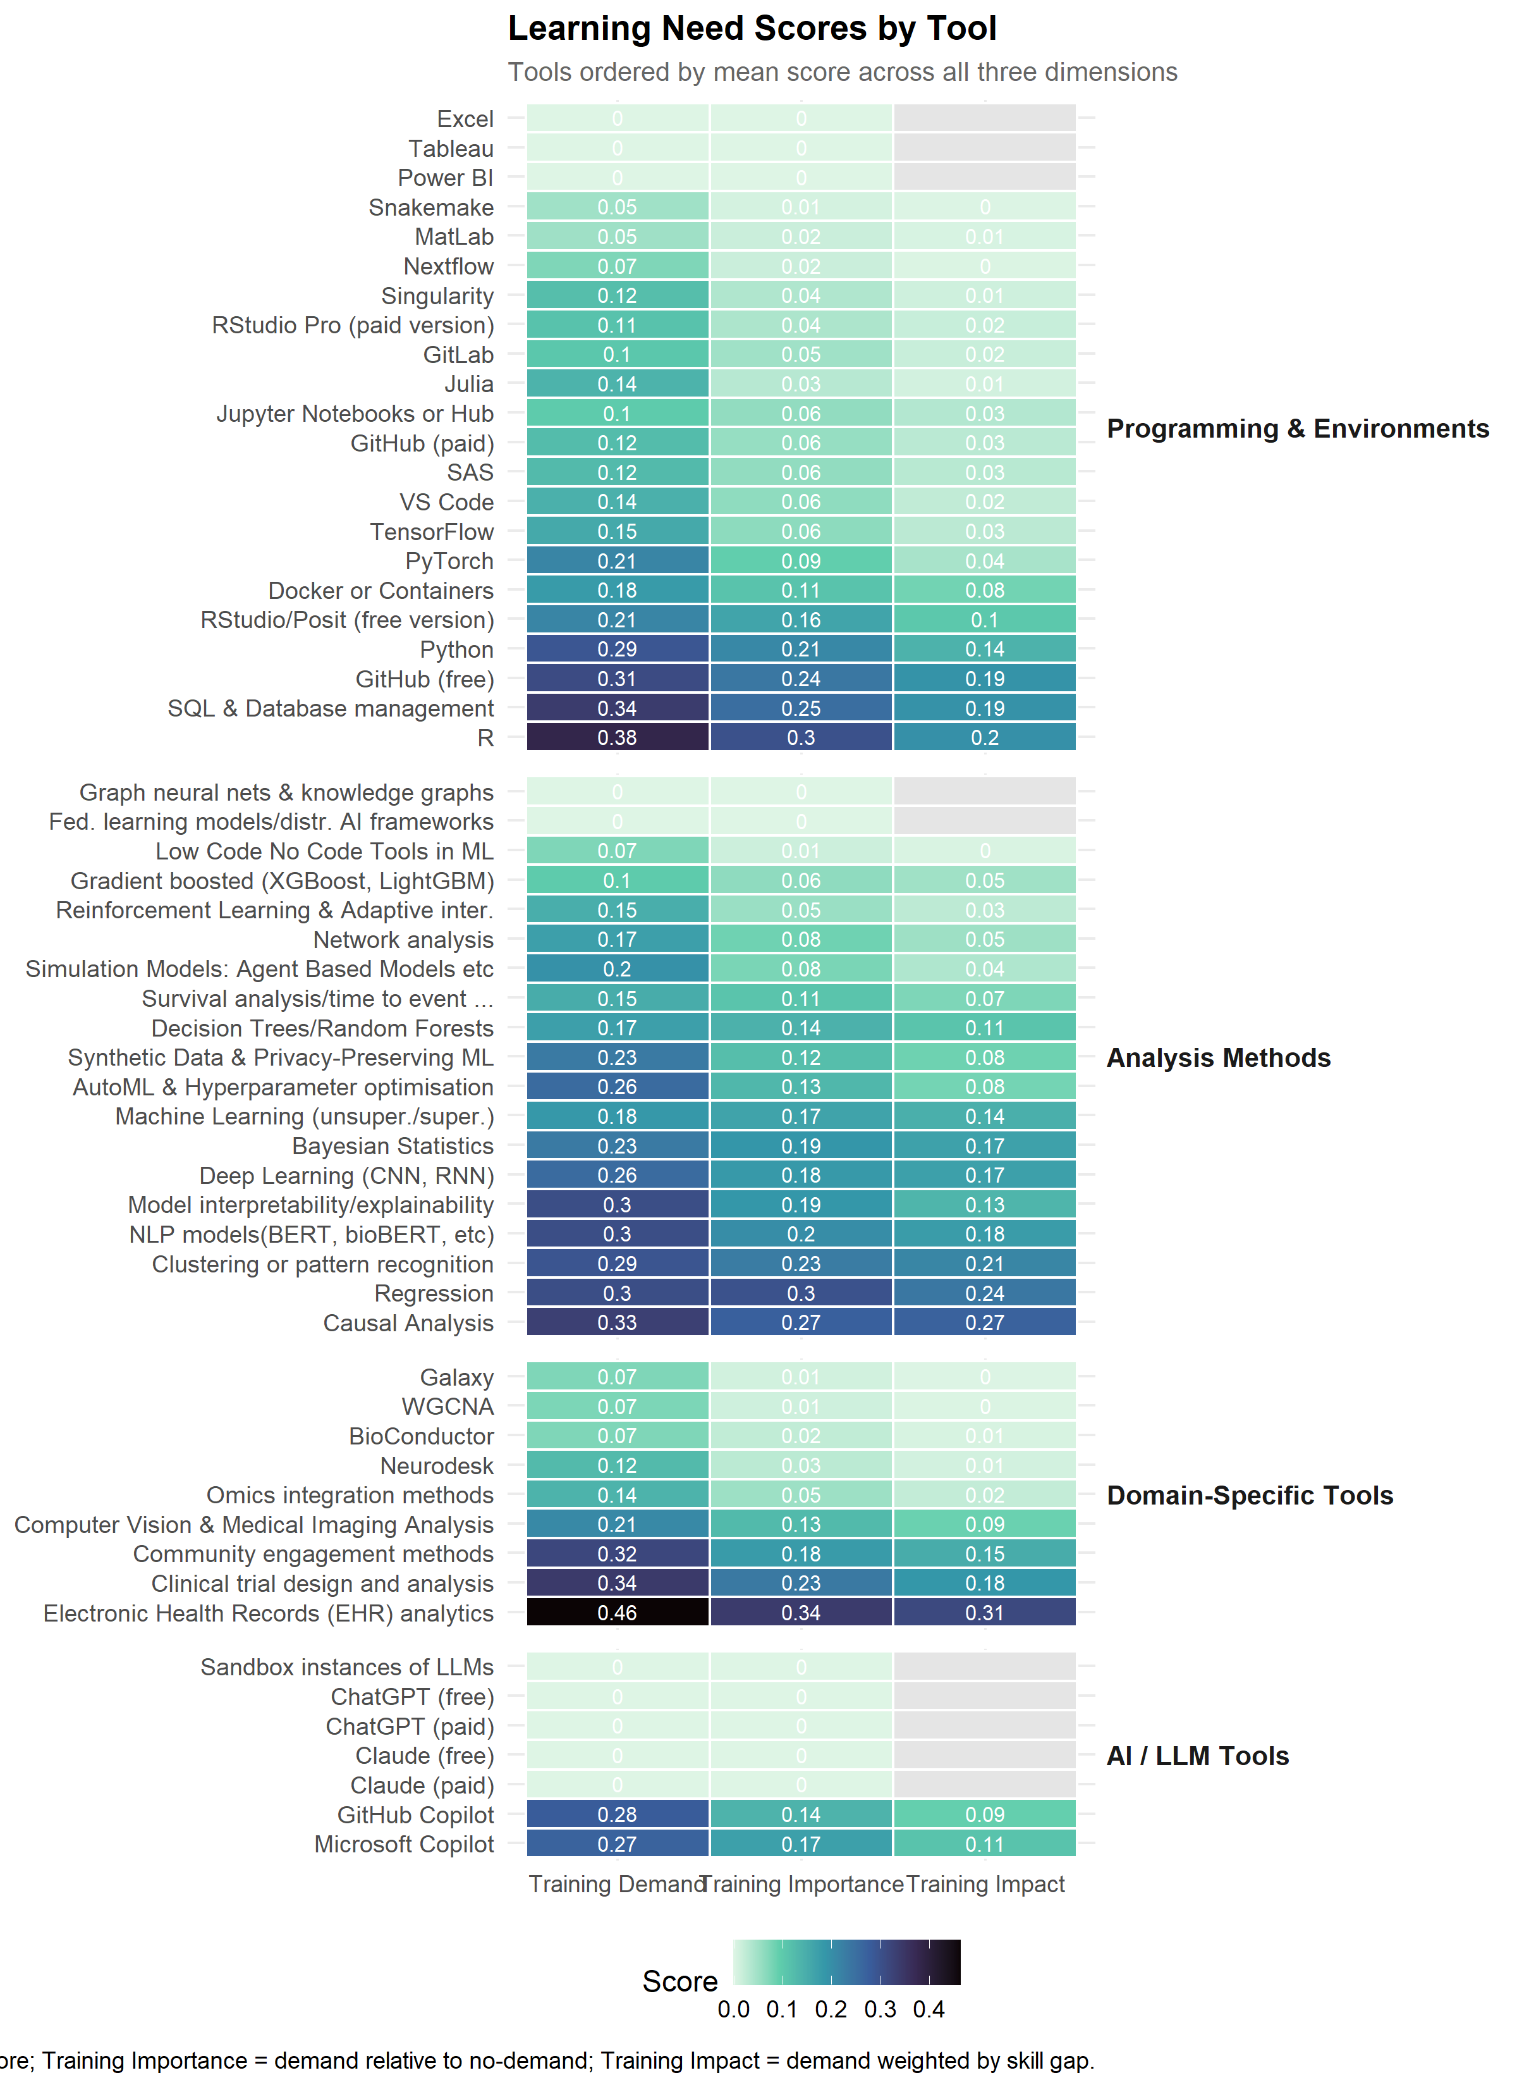
Heatmap of demand, importance and impact scores

